LGBTQIA+

Plan

Acknowledgment of Country
We acknowledge the Whadjuk Nyoongar people, Traditional Owners of the lands and waters where the City of Perth is today and pay our respects to Elders past and present. Nyoongar peoples are the original inhabitants and Traditional Owners of the South West of Western Australia. While Nyoongar is identified as a single language there are variations in both pronunciation and spelling – Noongar, Nyungar, Nyoongar, Nyoongah, Nyungah, Nyugah, Yungar and Noonga. The City of Perth uses ‘Nyoongar’ which is reflected throughout this document except when specifically referring to an external organisation that utilises alternative spelling.

Alternative Formats
An electronic version of the City of Perth’s LGBTQIA+ Plan 2021-24 is available from www.perth.wa.gov.au. This document can be provided in alternate formats and languages upon request.
City of Perth
27 St Georges Terrace, Perth
GPO Box C120, Perth WA 6839
Telephone: (08) 9461 3333
Email: info@cityofperth.wa.gov.au

Photographer Credit
Most of the photography throughout this Plan is credited to Shortie Zito Photography. Perth local and proud member of the LGBTQIA+ community, Shortie is passionate about capturing the beauty and uniqueness of the people in her city and surroundings.

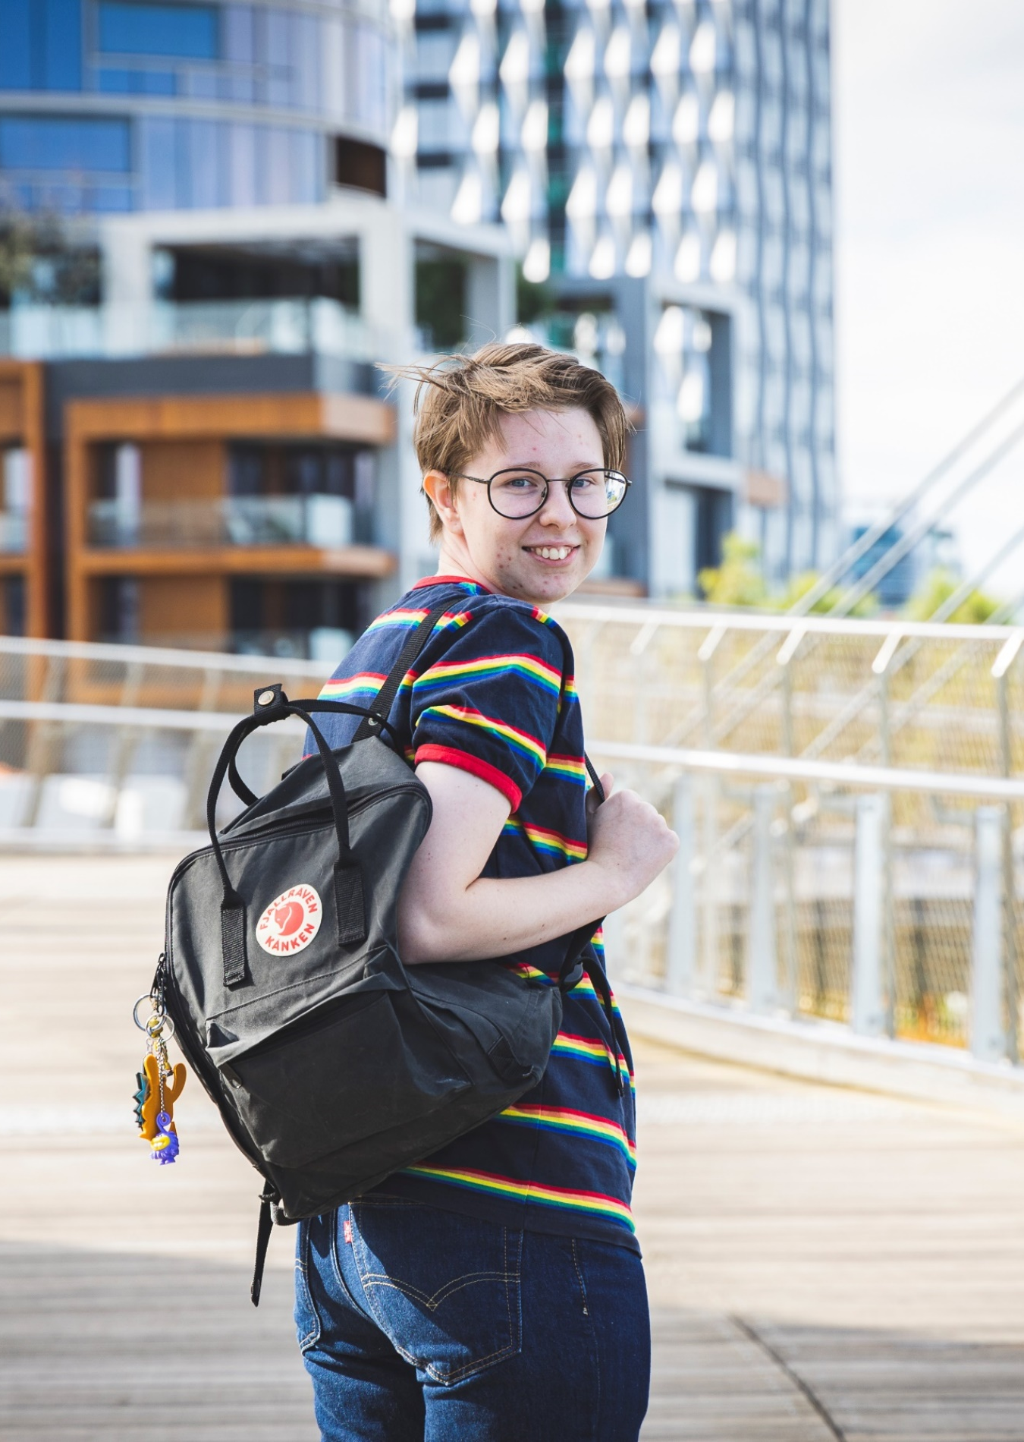
Terminology
This document uses the acronym LGBTQIA+, which refers to lesbian, gay, bisexual, transgender, queer, intersex and asexual, with the + symbol acknowledging the diversity of gender and sexuality not otherwise captured.
See page 54 for a full glossary of terms.
Sex characteristics are biological and physiological characteristics that includes chromosomal configuration, hormonal profile, reproductive organs and secondary sex characteristics such as breasts, body hair and voice (WA Department of Health, 2019).
Intersex is an umbrella term for people with physical characteristics that are seen as different from modern medical norms about ‘female’ and ‘male’ bodies (Q Life).
Gender Identity describes someone’s own understanding of who they are (e.g., woman, genderqueer, man, no gender, etc.), as distinct from their physical characteristics (Q Life).
Sexuality is a term used to describe an individual’s sexual, emotional and/or romantic attraction to another person.

Kaya Wanju

From the LGBTQIA+ Advisory Group
‘Hope will never be silent’ - we all have the right to live free from discrimination. violence and stigma - we all deserve to live in a city that embraces and welcomes the many communities that call it home.
The LGBTIQA+ Advisory Group - consisting of fifteen members has worked to embrace the ideals of co-design and co-delivery in order to build consensus through what is a historic community owned partnership.
As the first of its kind within the WA local government sector, it is truly a model for all.
While it was never an accident that forming a group from such diverse fields would produce such a powerful and heartfelt response - it’s rightfully one that no one should be scared of or nervous about.
We are indeed a passionate community, with many hopes and dreams. With many hopes and dreams. But they are ones of diversity, ones of inclusion and ultimately one of equality - ideals that can and do resonate far beyond.
We should all be proud that the City of Perth has embraced a genuine model of engagement to give action to these values in both statement, commitment and, most importantly, deliverable outcomes.
The City of Perth’s LGBTIQA+ Plan is a living document with recommendations embedded within the hopes of our entire community for meaningful progress.
Its legacy should be a signal that these community relationships, and the goodwill that follows, can lead to enduring change.
We would like to acknowledge the work and commitment of all the individuals across many networks whose goodwill and faith has been instrumental in the delivery of this comprehensive plan, including the City of Perth staff and our own community members.
In the spirit of further community building, we look forward to the City of Perth embarking on a new chapter that embraces inclusion.
By doing so, Perth as the ‘city of lights’ is surely destined to be a place that shines brightly with the flame of equality and that of hope made real through the voices of many.
From the LGBTQIA+ Advisory Group
David Goncalves | Paul-Alain Hunt
Advisory Group elected Co-Chairs City of Perth LGBTQIA+ Advisory Group | November 2021

Next Page:
L to R: Lauren Brophy (City of Perth), Hunter Gurevich, Andrew Hall, Curtis Ward, Katherine Sherrie (back), Caro Duca (front), Clint Woolly, David Goncalves, William Knox, Braden Hill, Paul-Alain Hunt, Kate Buckle, Kedy Kristal, Avery Wright, Steve Wellard, Bek Slavin (City of Perth).
Not shown: Emery Wishart, Dani Wright Toussaint, Sarah Feldman

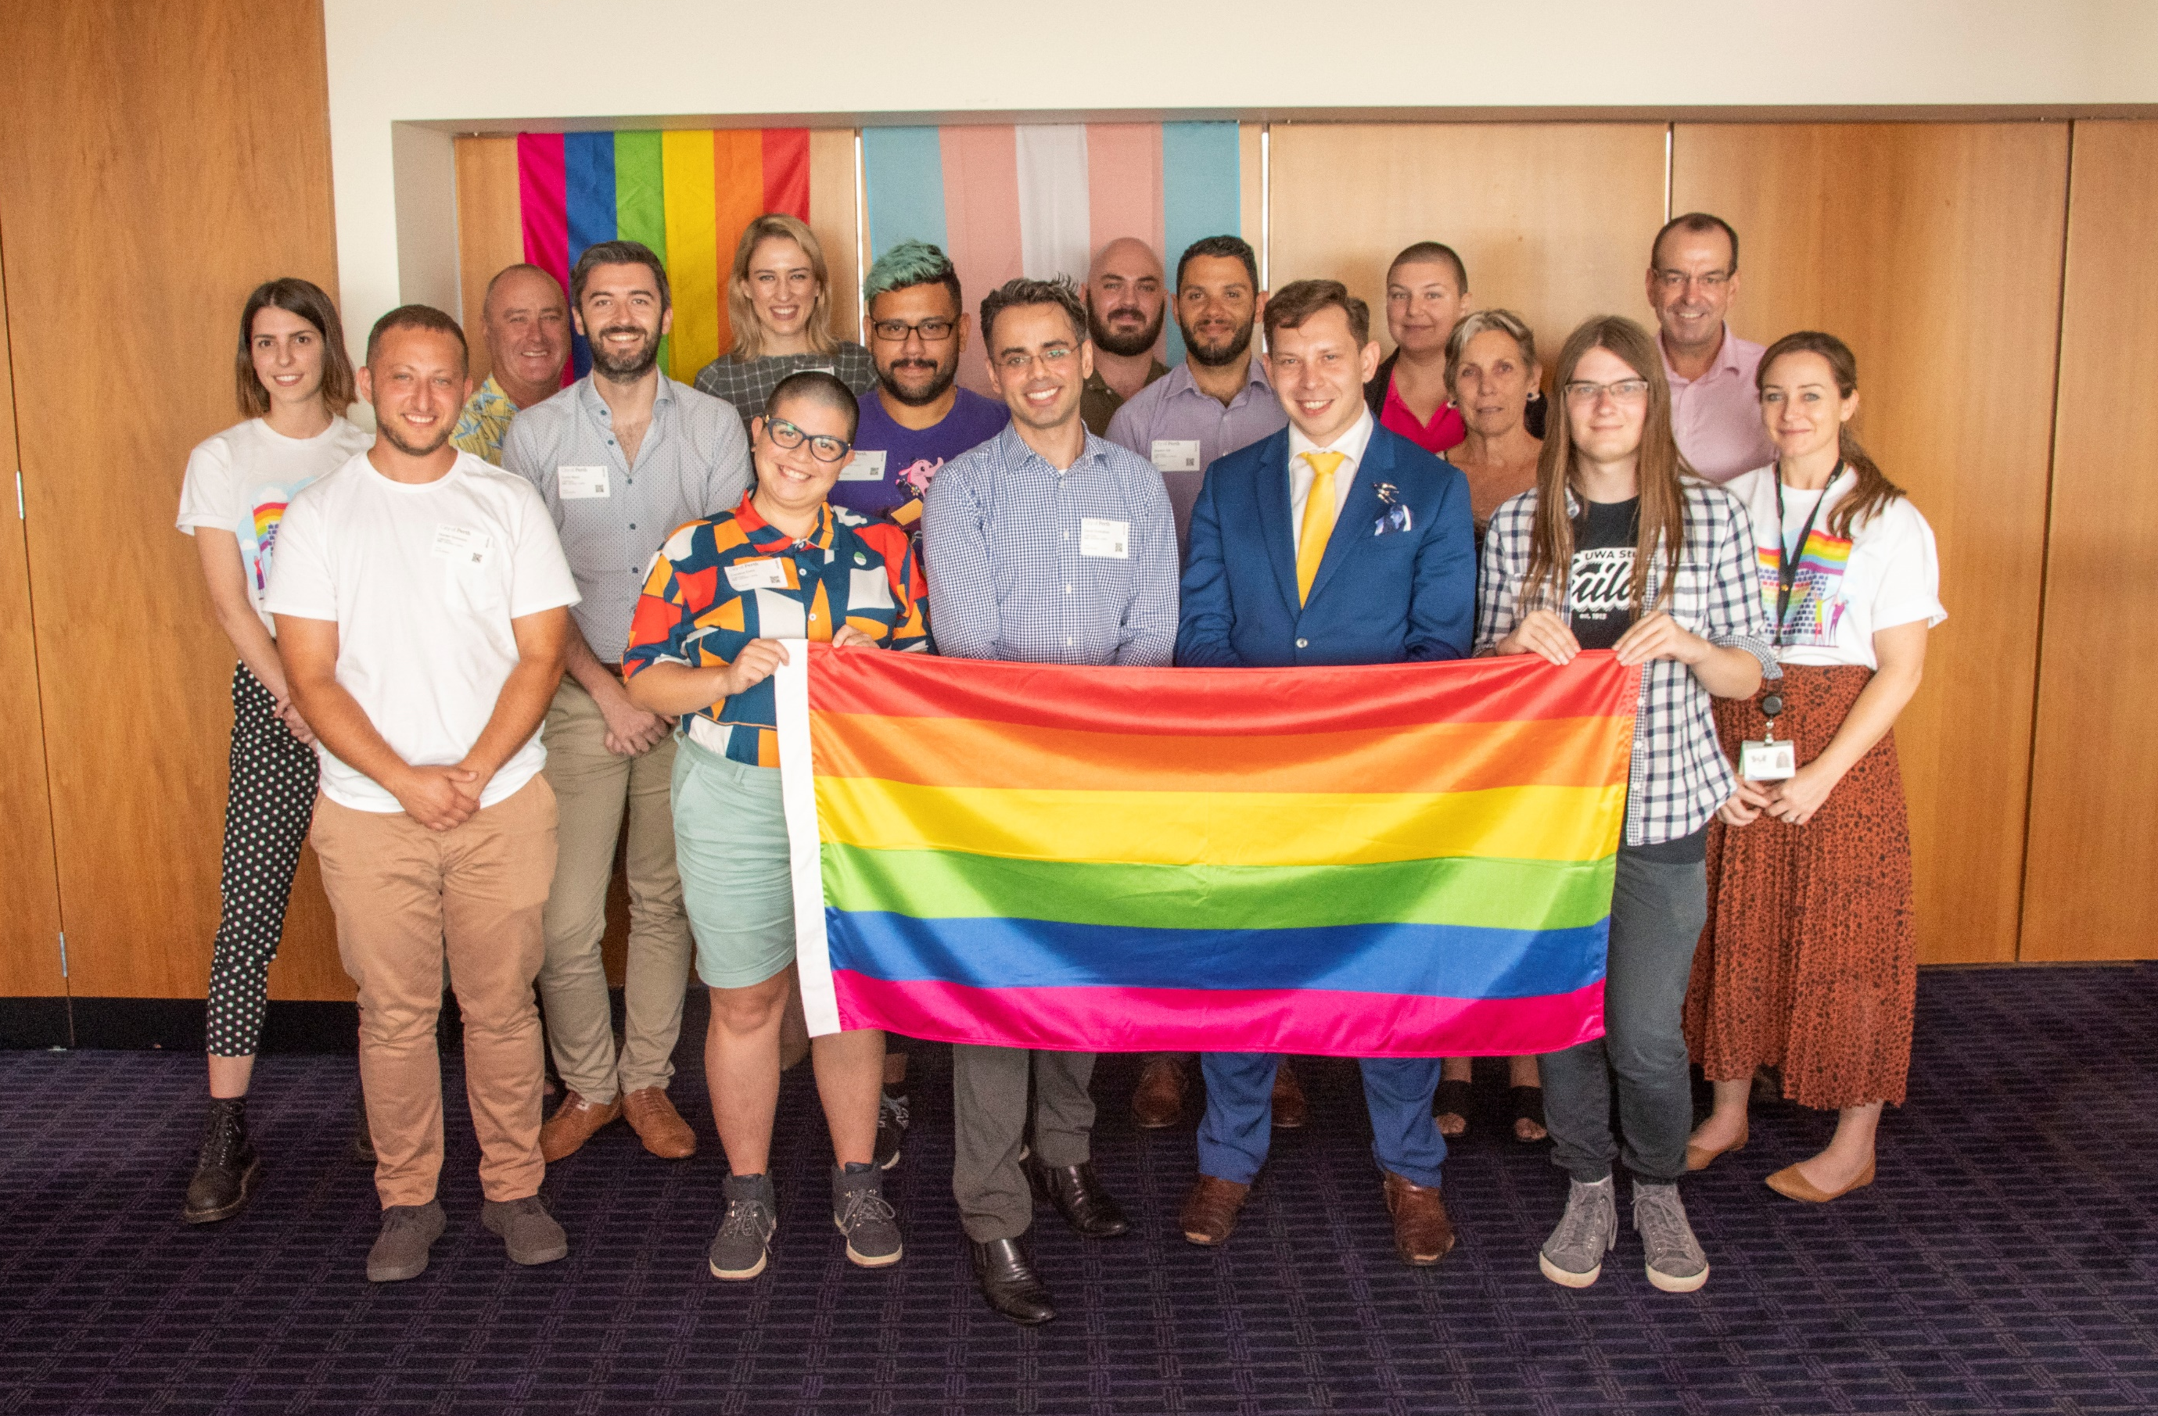

Kaya Wanju

From the Lord Mayor
Perth has a rich and lengthy LGBTQIA+ history. It is, and has been, a meeting place for LGBTQIA+ people across the State and as the City of Perth Council, we have a role to play in protecting and enhancing the lives of those who live, work and visit our city.
I acknowledge that we are on a journey of learning and, through close collaboration with the LGBTQIA+ community, we will be more visible in our leadership towards making Perth a safer place for LGBTQIA+ people.
On behalf of the Council, we are committed to valuing the diversity of our community and ensuring the City is welcoming and inclusive for all people.
BASIL ZEMPILAS
City of Perth Lord Mayor
November 2021

From the CEO
I am pleased to present the City of Perth’s first LGBTQIA+ Plan.
Thank you to those who participated in consultation and learning. We have heard you, and this plan reflects your feedback and aspirations for Perth.
Most importantly, thank you to the City of Perth’s LGBTQIA+ Advisory Group who have volunteered hours of their time to help us on this journey. Their dedication has been instrumental in the development of this plan. Thank you also to the internal working group for their commitment and allyship in bringing this document to life.
This three-year plan is ambitious, however it demonstrates our commitment to improving the experience of LGBTQIA+ people in the city.
We look forward to sharing the progress made with, and for, the community through this plan over the next three years.
MICHELLE REYNOLDS
City of Perth Chief Executive Officer
November 2021
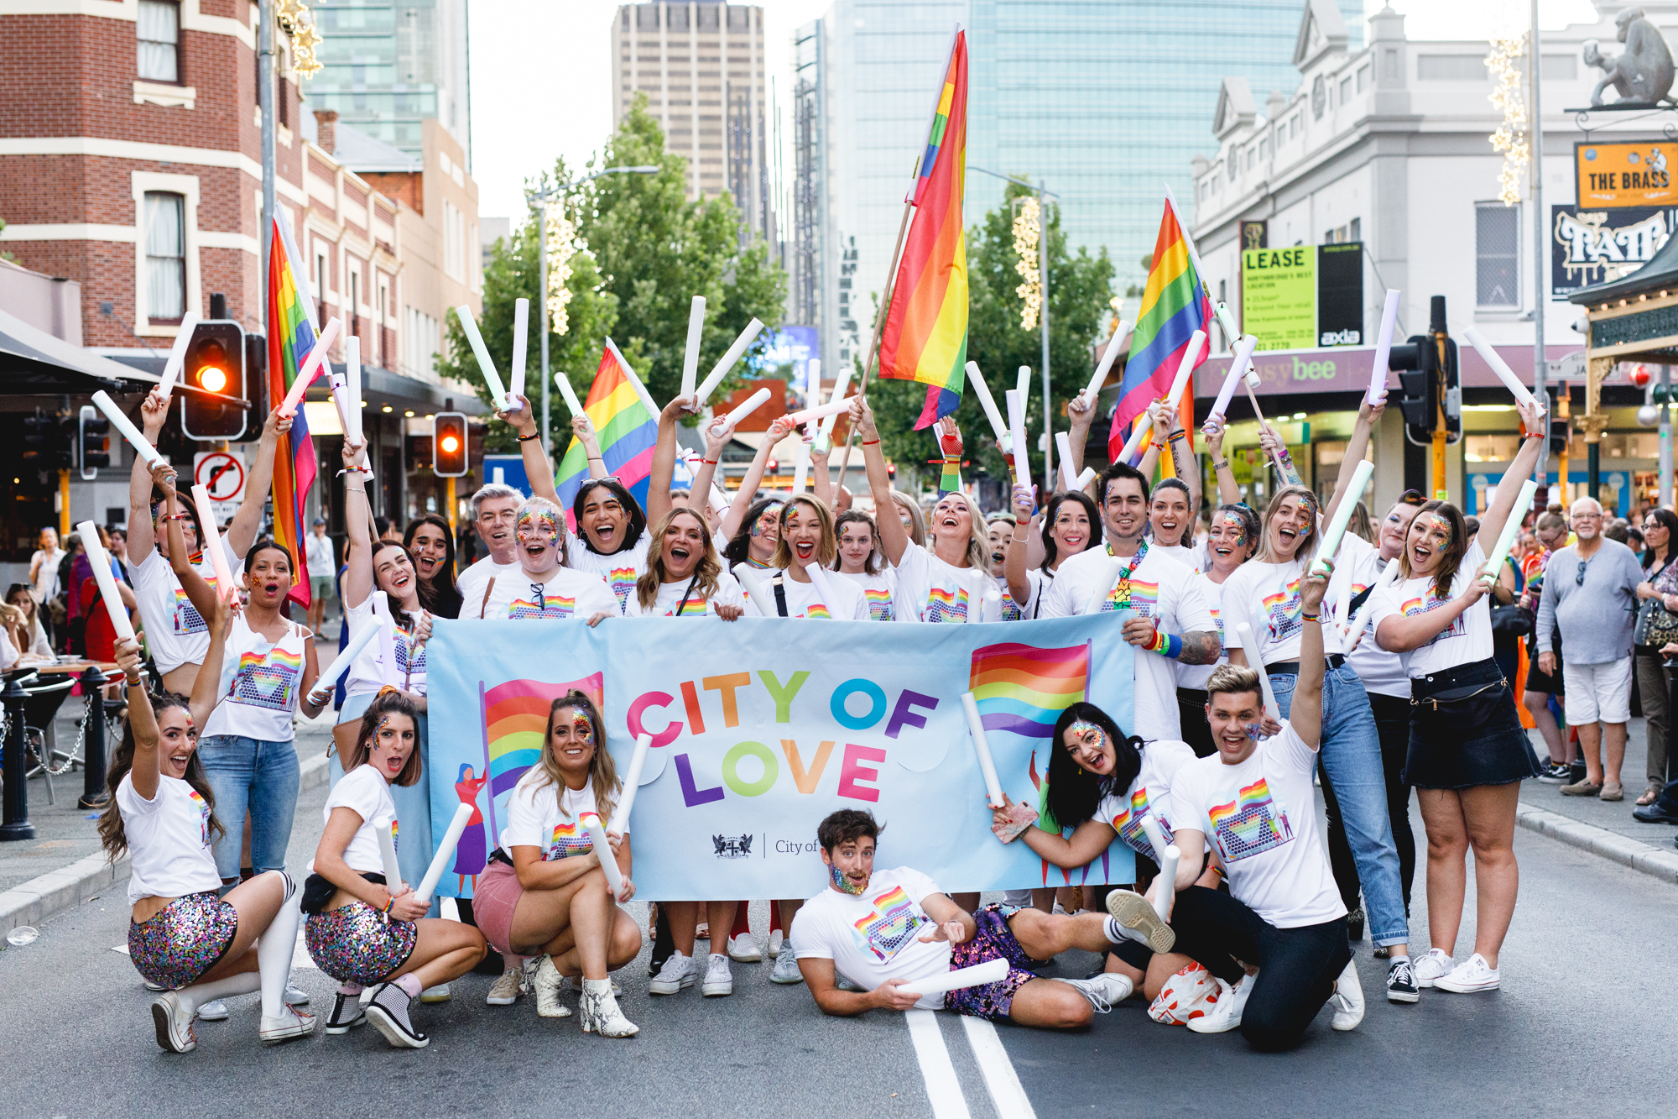


Contents

Introduction 10
Current State 12
Governance 22
Our Role 25
Guiding Principles 27
Action Area: Safety 28
Action Area: Education 32
Action Area: Homelessness 34
Action Area: Healthcare 35
Action Area: Organisational Capability 36
Action Area: Welcoming and Accessible Services 42
Action Area: Visibility 46
Capital City Advocacy 53
Evaluating the Plan 56
Glossary 57
References 60

Introduction
All people have an equal right to live free from violence, discrimination and stigma. Despite making headway in the last 20 years, the LGBTQIA+ community in Australia still faces a level of discrimination that sees people unable to access the same rights and dignity afforded to the broader community.
As a marginalised group, the LGBTQIA+ community is frequently under-represented, including in government. With an estimated 3,400 residents and 22,000 daily visitors who identify as having a diverse sexual orientation, sex or gender identity, this community represents a significant part of the City of Perth fabric.
The City has an opportunity, both as a local government representing a diverse population and as a Capital City, to support the LGBTQIA+ community as well as actively advocate with and for them. We can play a role in furthering social justice, celebrating diversity and promoting inclusion.
The City of Perth’s LGBTQIA+ Plan (the plan) represents an intentional and enthusiastic starting point in the journey towards improving the safety, visibility, social inclusion, health and wellbeing of the LGBTQIA+ community in the city.
Developed with input from the community across 523 engagements and in close collaboration with the City’s LGBTQIA+ Advisory Group, this three-year plan includes actions in seven areas:
- Safety;
- Education;
- Homelessness;
- Healthcare;
- Organisational Capability;
- Welcoming and Accessible Services; and
- Visibility.

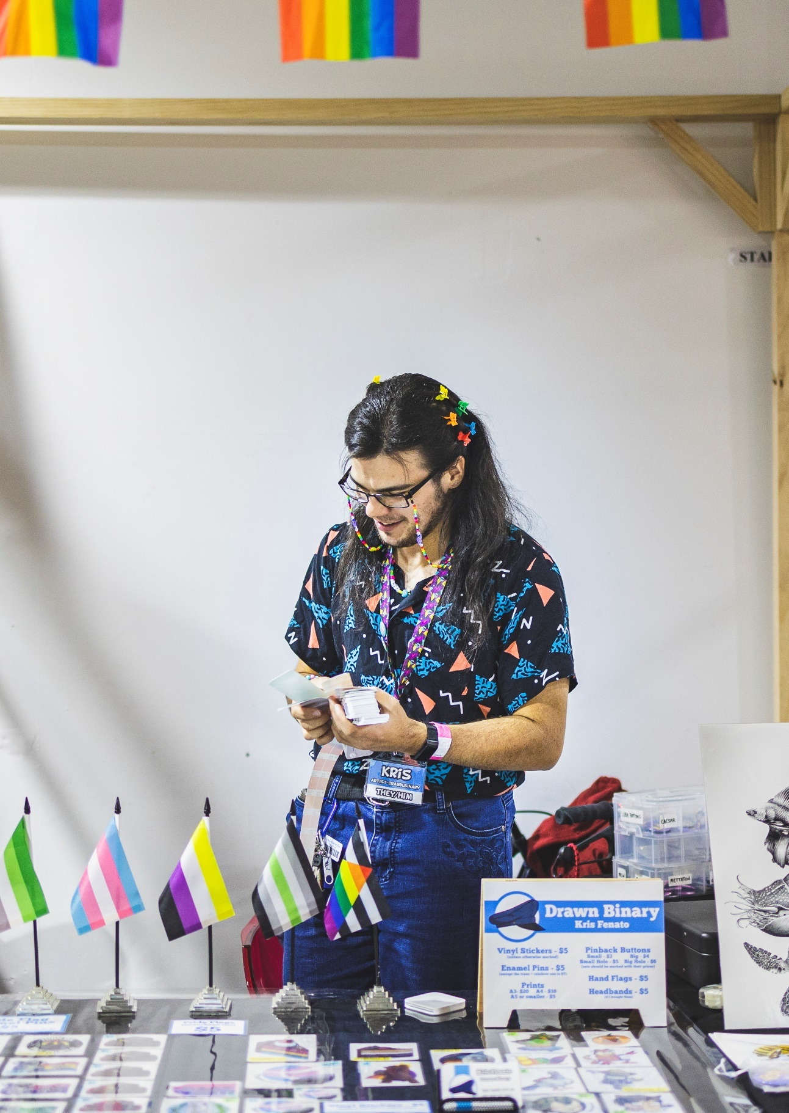
This plan contributes towards the City’s strategic pillars:
- Liveable
- Sustainable
- Prosperous
The City is committed, through this plan and the iterations that follow, to ongoing consultation, collaboration and action with and for the LGBTQIA+ community who visit, live and work in Perth.

Current State

Significant milestones in the fight for LGBTQIA+ equality in WA

LGBTQIA+ Community

In Australia and Western Australia

Department of Health 2012
2 Intersex Human Rights Australia 2019
3 Hillier et al. 2010

4 National LGBTI Health Alliance 2020

5 Strauss et al. 2017

⁶ LGBTQ DV Awareness Foundation 2021
Mental health challenges
LGBTQIA+ people experience homophobic and transphobic discrimination, harassment and abuse which results in poorer mental health compared to the general population.

In the City of Perth

Stakeholder Consultation Wellbeing Indicators
Through community and staff consultation, we’ve identified the following results which will be benchmarks to help evaluate the impact of this Plan.

Department of Health 2012
2 Australian Bureau of Statistics 2020
3 City of Perth WiFi sensors 2021
4 Intersex Human Rights Australia 2019

Strategic Context

Equity, Diversity and Inclusion Framework
In July 2021, the City of Perth developed an Equity, Diversity and Inclusion Framework. The Framework provides an overarching set of principles to guide all aspects of the organisation to ensure social justice is at the core of everything we do. The Framework is underpinned by existing and future plans, including this LGBTQIA+ plan.
The LGBTQIA+ Plan actively delivers on the five principles of the Framework. The existence of this plan addresses barriers to equitable participation (4) and actively embraces and celebrates the diversity of the LGBTQIA+ community (1). It was developed following community consultation (2) that will continue throughout its implementation. Through this consultation, the community identified additional principles specific to this plan (pg 25) and intersectionality (3) and leadership (5) were considered of such high importance they are also captured there.

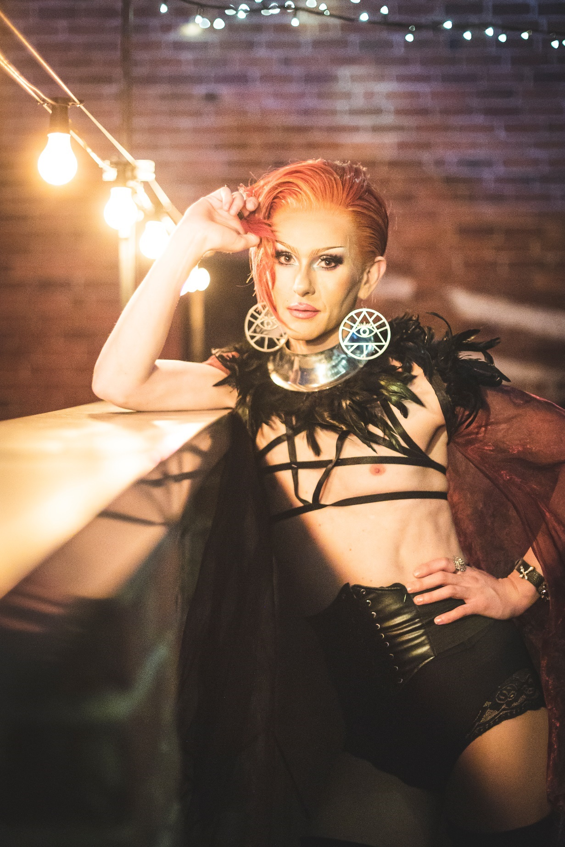
Where are we now?
The City of Perth has a rich history as the home of events and venues that celebrate LGBTQIA+ social life including most notably:
- Pride WA’s Pride Parade
- Perth Festival
- Fringe Festival
- Connections Nightclub
- The Court

The City has been a supporter of Pride Parade since 1999, more recently also lighting up Council House in rainbow colours and flying the Pride flag in recognition of Pride Month.
In addition, the City of Perth Library has a collection of LGBTQIA+ labelled books throughout the facility and curates displays to celebrate Pride Month.
The City of Perth is on a journey of acknowledging, supporting and addressing the rights of the LGBTQIA+ community and it is through this Plan that significant progress will be made.

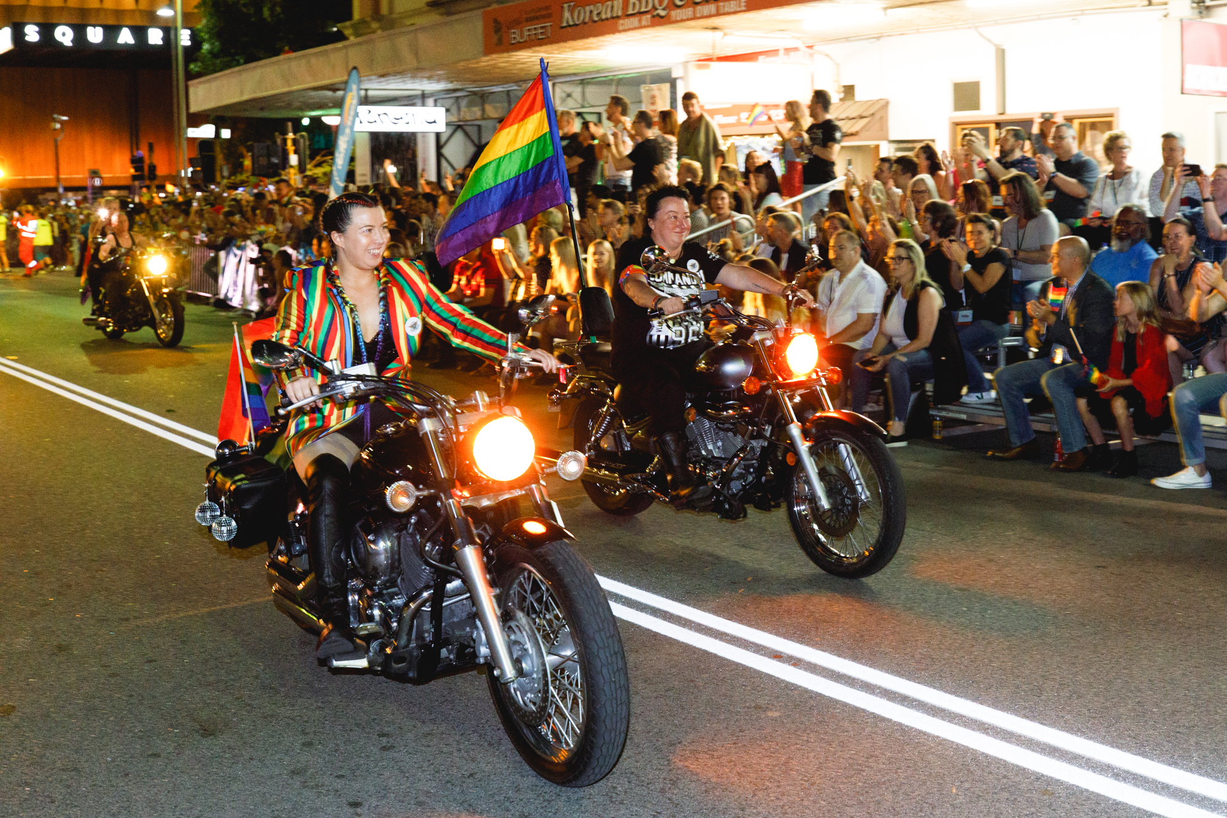

Stakeholder Engagement Summary
Between March and April 2021, the City conducted community consultation to benchmark experiences of LGBTQIA+ people in Perth and gather data to identify its role in acknowledging, supporting and addressing the rights of the LGBTQIA+ community. To learn more, refer to the Stakeholder Engagement Outcomes Report available on the City of Perth website.
The draft plan was available for community review during August 2021 with 48 comments received. This final plan reflects the outcomes of that review.
Engagements undertaken
3 | LGBTQIA+ Advisory Group meetings
2 | Community and organisation workshops
1 | Internal working group workshop
1 | Community questionnaire
1 | Staff questionnaire
Who was engaged
15 | LGBTQIA+ Advisory Group members
30 | Community and organisation members
16 | Internal working group members
359 | Community questionnaire respondents
103 | Staff questionnaire respondents
523 | Total engagements
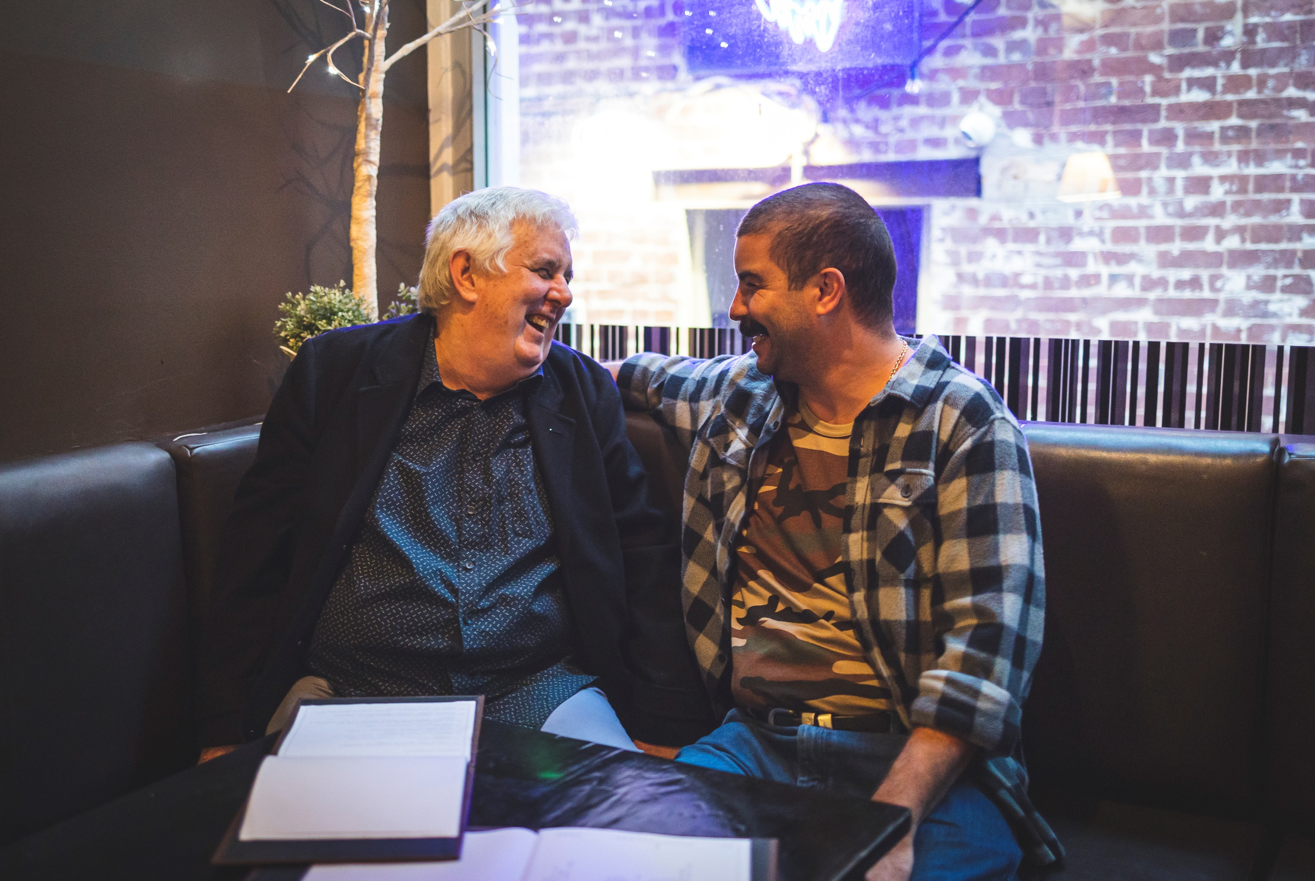

Governance

International Human Rights
Failure to uphold the human rights of LGBTQIA+ people and protect them against abuses such as violence and discriminatory laws and practices, constitute serious violations of international human rights law and have a far-reaching impact on society.
It’s important to recognise the role the actions in this Plan play in the global plight of humanity, including how they relate to the United Nation’s 17 Sustainability Development Goals.

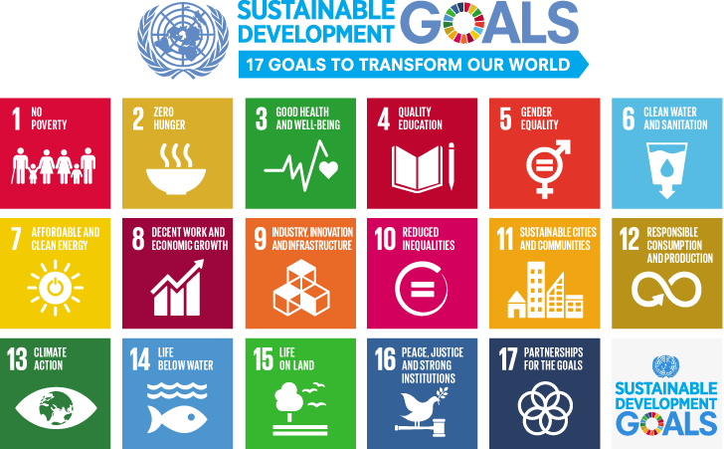 | End poverty in all its forms everywhere.  [Target 1.2] |  | Ensure healthy lives and promote well-being for all at all ages. [Target 3.3, 3.7]
 | Ensure inclusive and equitable quality education and promote lifelong learning opportunities for all. [Target 4.5, 4.a] |  | Promote sustained, inclusive and sustainable economic growth, full and productive employment and decent work for all.  [Target 8.8]
 | Reduce inequality within and among countries. [Target 10.2, 10.3, 10.4] |  | Make cities and human settlements inclusive, safe, resilient and sustainable.  [Target 11.1, 11.7]
 | Promote peaceful and inclusive societies for sustainable development, provide access to justice for all and build effective, accountable and inclusive institutions at all levels. [Target 16.1, 16.6, 16.7]

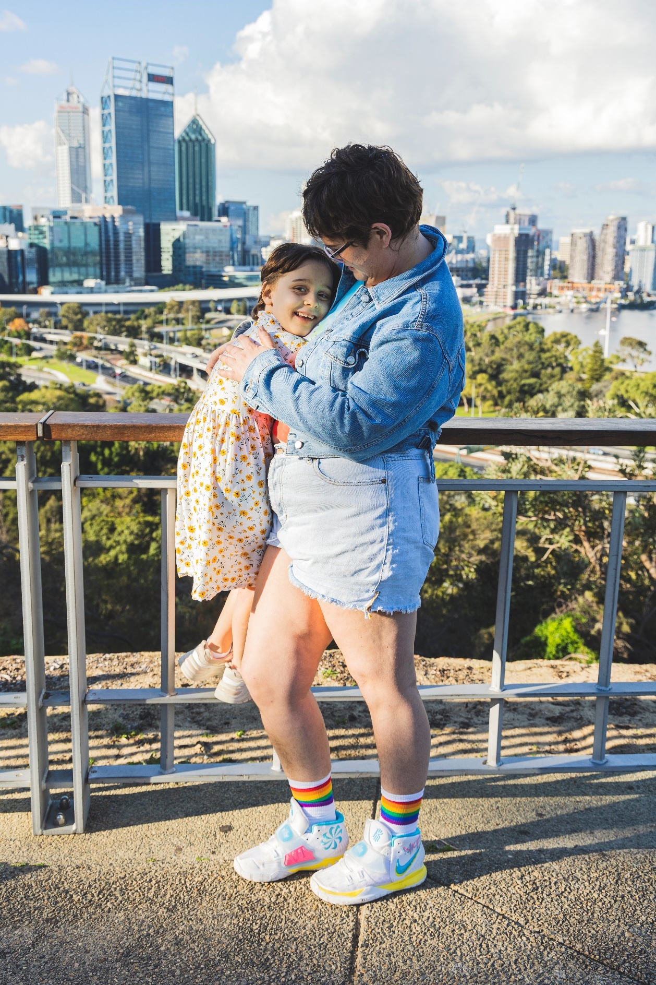
Relevant Legislation
- Australian Human Rights Commission Act 1986 (Cth)
- Sex Discrimination Act 1984 (Cth)
- Equal Opportunity Act 1984
- Acts Amendment (Lesbian and Gay Law Reform) Act 2002 (WA)

Internal LGBTQIA+ Working Group
The Internal LGBTQIA+ Working Group consists of 20 City of Perth staff members across 12 Business Units. The Group’s purpose is to assist with the development and implementation of the Plan, to champion the project and to set an example as LGBTQIA+ allies.

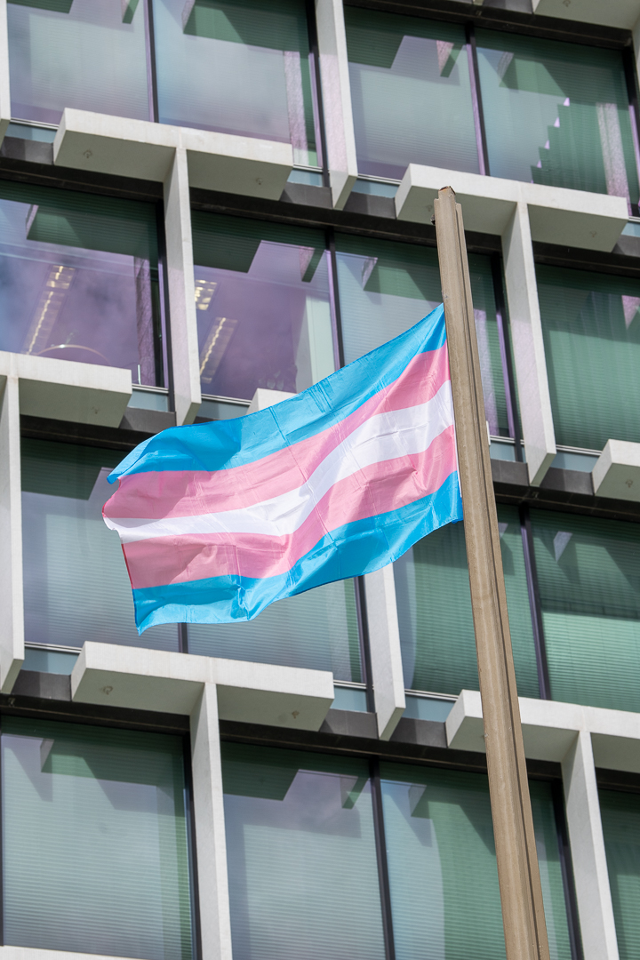
LGBTQIA+ Advisory Group
The City of Perth’s LGBTQIA+ Advisory Group, which was formed in February 2021, includes 15 members representing a broad-cross section of the LGBTQIA+ community and bringing intersectional expertise from the perspectives of older people, youth, homelessness, Aboriginal and Torres Strait Islander, CALD and disability sectors.
The group have been instrumental in representing the community and guiding the City in the development of this Plan.
Avery Wright | David Goncalves | Paul-Alain Hunt
Braden Hill | Hunter Gurevich (proxy Emery Wishart) | Perth Inner City Youth Service (PICYS) represented by Dani Wright Toussaint and Andrew Hall (shared seat)
Caro Duca | Kate Buckle | Sarah Feldman
Clint Woolly | Katherine Sherrie | Steve Wellard
Curtis Ward | Kedy Kristal | William Knox

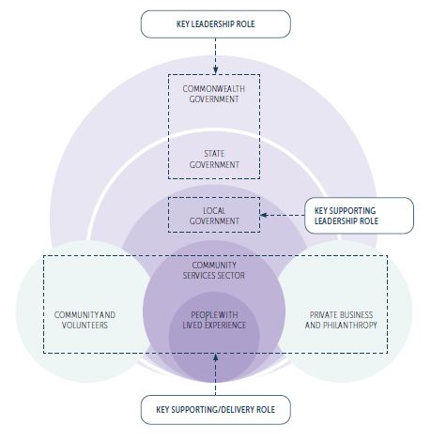
Our Role
The City of Perth Act 2016 defines the responsibility the City has in representing the broader Perth area and the State of Western Australia on both a national and international level.
Through this Plan, we undertake multiple roles:
 | FACILITATOR: We facilitate others to deliver services and programs to the community.
 | SERVICE PROVIDER: We play a lead role in delivering services and programs directly to the community.
 | PARTNER: We build partnerships with others to assist in the delivery of services and programs to the community.
Page 51 outlines the positions the community have identified as priorities and addresses the City’s role of:
ADVOCATE: We advocate on behalf of the community to influence the delivery of services and programs to meet the needs of the community.

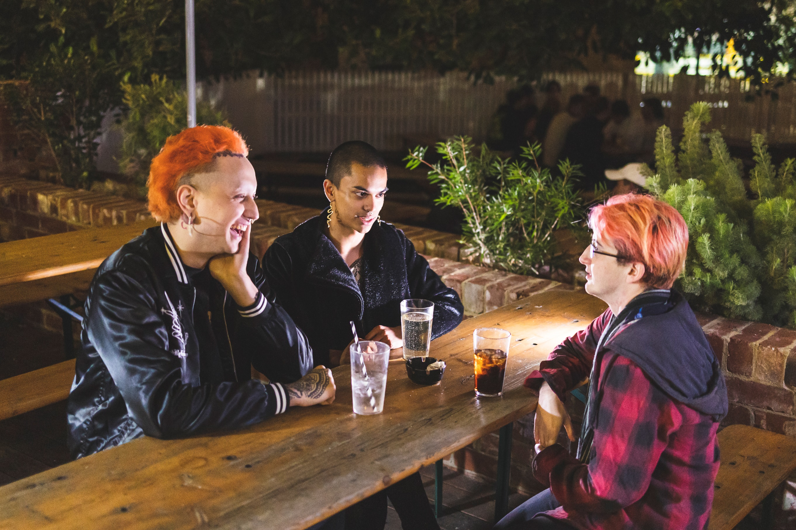

Guiding Principles
Recognising intersectionality
Intersectionality recognises that discrimination exists within discrimination. The experiences of LGBTQIA+ people who are also BIPOC (Black, Indigenous and People of Colour), living with a disability, seniors or youth can be markedly different to that of the general LGBTQIA+ population and of course the wider population.
The actions in this Plan need to address intersections in the LGBTQIA+ experience and speak to other Plans designed to foster equity, such as the Access and Inclusion Plan and the Reconciliation Action Plan.

Creating safe spaces
Celebration and visibility are valuable to the LGBTQIA+ community however, they have indicated that there are important systemic improvements that also need to happen to make Perth a safer place for them. This Plan focuses on increasing safety through action.

Delivering through co-design
The community would like to see LGBTQIA+ organisations be supported to a greater degree and see the role and responsibility of the City of Perth in assisting with capacity building and facilitating growth and development in these organisations.
Capital City leadership
The City of Perth, as a Capital City, can demonstrate strong leadership to encourage other Perth Councils to act so that the positive steps the City is taking are demonstrated across the broader metropolitan area. The community is seeking increased collaboration between local and state government, with the City of Perth leading best practice and providing strong advocacy in the appropriate areas.

Action Area:
Safety
These actions work to ensure LGBTQIA+ people, and the wider community, feel safe living, visiting, studying and working in the City of Perth. We strive for physical and mental safety both in the public realm and online. A feeling of safety is crucial to allowing people to be themselves, fostering belonging and creating an environment where people can thrive.
 | Action | Expected timeframe |  |  | Success measure | Related action areas
 |  | 21/22 | 22/23 | 23/24
1 | Train security and law enforcement to be allies to the LGBTQIA+ community, ensuring they’re visibly identifiable.
1.1 | City of Perth Safe City Officers and Rangers to complete trans awareness training to gain a greater understanding of the safety concerns of transgender and gender diverse people. | X | X | X | 100% completion of trans awareness training by Safe City Officers and Rangers. | Education  Visibility
1.2 | City of Perth Safe City officers and Rangers to be visibly marked as allies, where appropriate, following ally and trans awareness training. |  | X | X | Safe City Officers and Rangers visibly marked as allies following training.

 | Action | Expected timeframe |  |  | Success measure | Related action areas
 |  | 21/22 | 22/23 | 23/24
2 | Increase the number of public all gender bathrooms in the City of Perth.
2.1 | Investigate opportunities to provide all gender bathrooms and change facilities in City of Perth owned and operated venues. |  | X | X | All gender bathrooms included in planned upgrades. | Welcoming and Accessible Services
2.2 | Include the provision of all gender bathrooms and change facilities when updating the Public Toilet Plan. |  | X | X | Public Toilet Plan reviewed and updated.
2.3 | Investigate opportunities to encourage inclusion of all gender bathrooms in developments through the new Local Planning Scheme No. 3. |  | X |  | Local planning policies and schemes reviewed and updated. | Welcoming and Accessible Services

 | Action | Expected timeframe |  |  | Success measure | Related action areas
 |  | 21/22 | 22/23 | 23/24
3 | Understand and act on incidents of discrimination and harassment within City of Perth boundary to make the City a safer place for LGBTQIA+ people.
3.1 | Review and update the complaints process and employee education to provide clear internal direction (and potentially investigation and resolution procedures) for the City to follow if someone experiences LGBTQIA+ related discrimination, harassment and/or assault in the City of Perth. | X |  |  | Complaints process reviewed and updated. Customer Experience staff trained in process.
3.2 | Provide and promote information to support the community in reporting LGBTQIA+ related discrimination, harassment and/or assault, including information on reporting to the City of Perth, Human Rights Commission, Equal Opportunity Commission of WA or Police where appropriate – as well as information on surrounding support services. | X | X | X | Information available online and promoted in public realm.

 | Action | Expected timeframe |  |  |  | Success measure | Related action areas
 |  | 21/22 |  | 22/23 | 23/24
3.3 | Commence investigating and undertaking capacity building with the businesses/ organisations identified to the City through the process developed in Action 3.1. |  |  | X | X | Complaints are directed to the appropriate third- party  agency or dealt with internally as appropriate. | Welcoming and Accessible Services
3.4 | Undertake capacity building with the businesses/organisations identified to the City through the process developed in Action 3.1 to help support them to be safe spaces for the community. |  |  | X | X | Develop an evaluation benchmark to measure capacity built in organisation. | Welcoming and Accessible Services

Action Area:
Education
These actions provide formal and informal education to various groups in the community through the sharing of information digitally and physically.

 | Action | Expected timeframe |  |  |  | Success measure | Related action areas
 |  | 21/22 |  | 22/23 | 23/24
4 | Provide LGBTQIA+ educational resources for the community to help the public understand how they can be allies, and assist the LGBTQIA+ community with accessing services.
4.1 | Commence the process of working with local LGBTQIA+ and allied organisations (subject matter experts) to undertake capacity building with businesses and other organisations within the City of Perth to help them understand the needs of the LGBTQIA+ community and learn how to be allies. |  |  | X | X | Capacity building initiatives delivered, as determined. | Welcoming and Accessible Services

 | Action | Expected timeframe |  |  |  | Success measure | Related action areas
 |  | 21/22 |  | 22/23 | 23/24
4.2 | Develop a printed resource in line with other equity, diversity and inclusion materials, of LGBTQIA+ services and stakeholders for distribution through City of Perth owned venues and available online. |  | X | X | X | Printed resource developed and distributed.
4.3 | Work with Culturally and Linguistically Diverse (CaLD) organisations to ensure resource developed in 4.2 is available in languages that are highly represented in the Perth LGBTQIA+ community. |  |  | X | X | Multilingual resource/s developed based on community need. | Welcoming and Accessible Services
4.4 | Undertake community capacity building by funding free LGBTQIA+ education/information sessions and ally training sessions for community members to attend. |  |  | X | X | Delivery of session/s and training to community.
5 | Develop a Communications Plan to support the implementation of the LGBTQIA+ Plan, raising awareness of the needs of the LGBTQIA+ community by sharing details of the initiatives the City is undertaking. |  | X | X | X | Communications Plan developed and delivered. | Visibility

Action Area:
Homelessness
‘Homelessness’ is defined as anyone with unstable housing including primary, secondary and tertiary homelessness. These actions recognise at-risk groups including youth, seniors and trans and gender diverse people and acknowledge the underlying drivers of LGBTQIA+ homelessness such as parental support and intimate partner and family violence.

 | Action |  | Expected timeframe |  |  |  |  | Success measure | Related action areas
 |  |  | 21/22 |  | 22/23 |  | 23/24
6 |  | Incorporate existing research on lived experiences and engagement with LGBTQIA+ people experiencing homelessness into any future City of Perth plans responding to community needs related to homelessness including the implementation of the Rough Sleeper Plan. |  | X |  | X | X | Lived experiences and engagement with LGBTQIA+ people incorporated into homelessness plans and implementation.
7 |  | Investigate and advocate to mobile homeless healthcare services to ensure LGBTQIA+ and sexual healthcare education and services are incorporated into existing services. |  | X |  |  |  | Conversation had with healthcare services. | Healthcare

Action Area:
Healthcare
These actions address mental health, sexual health (including STIs, HIV, fertility and family planning services) and social wellbeing and connectedness. They also acknowledge the unique needs of trans and gender diverse people and intersex people.
 | Action |  | Expected timeframe |  |  |  |  | Success measure | Related action areas
 |  |  | 21/22 |  | 22/23 |  | 23/24
8 |  | Promote Grants and Sponsorship program to LGBTQIA+ community groups and service providers to assist them with delivering inclusive, welcoming and targeted LGBTQIA+ lifestyle programming, community support groups and check in services. |  | X |  | X | X | Grants and Sponsorship program promoted to LGBTQIA+ community groups. | Welcoming and Accessible Services
9 |  | Consider how to support sexual health providers in delivering sexual health services in the city as part of the Public Health and Wellbeing Plan. |  |  |  | X | X | Meetings held with sexual health providers. | Homelessness
10 |  | City of Perth Safe City Officers and Rangers to complete suicide prevention, mental health and substance abuse awareness training that includes an LGBTQIA+ focus. |  |  |  | X | X | 100% completion of training by Safe City Officers and Rangers. | Safety

Action Area:
Organisational Capability
These actions establish inclusive and supportive policies and governance, spearheaded by strong leadership at all levels.

 | Action | Expected timeframe |  |  |  |  |  | Success measure | Related action areas
 |  | 21/22 |  | 22/23 |  | 23/24
11 | Conduct regular engagement with LGBTQIA+ stakeholders and community to ensure the City of Perth continues to meet the expectations of the community.
11.1 | Continue to engage the LGBTQIA+ Advisory Group or similar to monitor the implementation of the LGBTQIA+ Plan and expand the scope to advise on more City projects, as appropriate. |  | X |  | X |  | X | Advisory Group or similar, meeting quarterly at a minimum.
11.2 | Incorporate LGBTQIA+ engagement in the City’s Stakeholder Engagement Framework to ensure LGBTQIA+ voices are represented in all City projects. |  | X |  |  |  |  | LGBTQIA+ engagement added to Stakeholder Engagement Framework.
 | Action | Expected timeframe |  |  |  |  |  | Success measure | Related action areas
 |  | 21/22 |  | 22/23 |  | 23/24
12 | All City employees to complete mandatory LGBTQIA+ ally training.
12.1 | Frontline staff, Human Resources (HR), Managerial Leadership Team (MLT) and Executive Leadership Team (ELT) to complete mandatory LGBTQIA+ ally training workshop with a refresher every two years. |  | X |  | X |  | X | 95% completion of training workshop by frontline staff, HR, MLT and ELT. | Education  Welcoming and Accessible Services
12.2 | Develop a module on City Learn for new and existing employees which covers diversity and inclusion, LGBTQIA+ ally training and highlights the City’s commitment to the LGBTQIA+ community through relevant policies and procedures to contribute to a safe working environment. |  | X |  | X |  |  | Module developed and incorporated into induction. | Education
12.3 | All staff to complete mandatory online module as developed in Action 12.2, with a refresher every two years. |  | X |  | X |  | X | 90% completion of online training by staff. | Education

 | Action |  | Expected timeframe |  |  |  |  |  |  |  |  | Success measure | Related action areas
 |  |  | 21/22 |  |  | 22/23 |  |  | 23/24
12.4 | All customer facing City volunteers to complete LGBTQIA+ ally training workshop. |  |  |  |  |  | X |  |  | X |  | 95% completion of training workshop by customer facing City volunteers. | Education  Welcoming and Accessible Services
13 | All Elected Members and Committee Members to complete mandatory LGBTQIA+ ally training.
13.1 | Current Elected Members and Committee Members to complete LGBTQIA+ ally training workshop. |  |  | X |  |  |  |  |  |  |  | 100% completion of training workshop by current Elected Members and Committee Members. | Education
13.2 | New Elected Members and Committee Members to complete ally training workshop as part of induction which also highlights the City’s commitment to the LGBTQIA+ community through relevant policies and procedures to contribute to a safe working environment. |  |  | X |  |  |  |  |  | X |  | 100% completion of training workshop by new Elected Members and Committee Members. | Education
 | Action |  | Expected timeframe |  |  |  |  |  |  |  |  | Success measure | Related action areas
 |  |  | 21/22 |  |  | 22/23 |  |  | 23/24
14 |  | Update Elected Member, Committee Member and Candidate Code of Conduct when next reviewed to specifically reference zero tolerance of homophobia and transphobia and embed as enforceable provision of the Code. |  |  |  |  |  | X |  |  |  | Code of Conduct updated.
15 |  | Update Officer Code of Conduct to specifically reference zero tolerance of homophobia and transphobia, with clear course of action for breach of Code. |  |  | X |  |  |  |  |  |  | Code of Conduct updated.
16 |  | Increase LGBTQIA+ diversity within City of Perth workforce.
16.1 |  | Proactively encourage both internal and external applications from LGBTQIA+ people and promote the City of Perth as a safe place to work. |  |  |  |  |  | X |  |  | X | Recruitment information reviewed and updated.
16.2 |  | Appoint an LGBTQIA+ champion (and senior management sponsor), preferably with lived experience, at depot, Council House and community facilities. |  |  |  |  |  | X |  |  |  | LGBTQIA+ champions appointed and promoted to staff.
 | Action |  | Expected timeframe |  |  |  |  |  |  |  |  | Success measure | Related action areas
 |  |  | 21/22 |  |  | 22/23 |  |  | 23/24
17 |  | Engage with a support, accreditation or ranking program for LGBTQIA+ workplace inclusion and achieve benchmark standard using local organisations for support. |  |  |  |  |  | X |  |  | X | Organisation submission made.
18 |  | Review and update policy and diversity practices for LGBTQIA+ inclusion. |  |  | X |  |  | X |  |  | X | All policies reviewed and updated as required. | Welcoming and Accessible Services
19 |  | Review grievance policy and process, including support systems for affected employees to be LGBTQIA+ inclusive. |  |  | X |  |  | X |  |  | X | Grievance policy and process reviewed and updated. | Welcoming and Accessible Services
20 |  | Review and update policies, processes and practices for trans and gender diverse inclusion. |  |  |  |  |  | X |  |  | X | Policies, processes and practices reviewed and updated. | Welcoming and Accessible Services
21 |  | Review all customer facing and staff interactions to ensure they’re LGBTQIA+ inclusive.

 | Action |  | Expected timeframe |  |  |  |  |  | Success measure | Related action areas
 |  |  | 21/22 |  | 22/23 |  | 23/24
21.1 |  | Review all Customer Experience platforms, policies and formats to ensure inclusive language and practices. |  | X |  | X |  |  | Customer Experience platforms, policies and formats reviewed and updated. | Welcoming and Accessible Services
21.2 |  | Review internal and external facing forms and IT systems to allow non-binary gender options or remove gender questions altogether when not necessary. |  | X |  | X |  |  | Internal and external, paper and online forms are updated. | Welcoming and Accessible Services

Action Area: Welcoming
and Accessible Services
These actions refer to facilities, infrastructure, spaces, events, venues etc. that are informed by the users and inclusive by default. They aim to ensure visitors bear no physical, financial or psychological cost or barrier in accessing them.
 | Action |  | Expected timeframe |  |  |  |  |  | Success measure | Related action areas
 |  |  | 21/22 |  | 22/23 |  | 23/24
22 |  | Support LGBTQIA+ organisations through the Grants and Sponsorships program to deliver more intersectional and inclusive services for the community, including but not limited to:  - Events  - Support services  - Safe, all-ages spaces  - Sporting programs  - Scholarships and mentor programs  - Small businesses  - Health services  - Pride Month specific activities
 | Action |  | Expected timeframe |  |  |  |  |  | Success measure | Related action areas
 |  |  | 21/22 |  | 22/23 |  | 23/24
22.1 |  | Review the Grants and Sponsorships program to ensure the language is inclusive, add an evaluation question for LGBTQIA+ inclusion and update the requirements to encourage submissions to include a “Diversity and Inclusion Plan”. |  |  |  | X |  | X | Grants and Sponsorships program reviewed and updated.
22.2 |  | Actively promote the Grants and Sponsorships program to LGBTQIA+ organisations. |  | X |  | X |  | X | Grants and Sponsorships program promoted to LGBTQIA+ groups. | Visibility  Safety
23 |  | Capacity building information provided to event and sporting club applicants to encourage them to deliver LGBTQIA+ inclusive events. |  |  |  | X |  | X | Inclusivity information developed and provided. | Safety
24 |  | Review City of Perth services to ensure LGBTQIA+ inclusion in operations and programming.

 | Action |  | Expected timeframe |  |  |  |  |  | Success measure | Related action areas
 |  |  | 21/22 |  | 22/23 |  | 23/24
24.1 |  | Review the Childcare Centre program to ensure LGBTQIA+ inclusive language is used. |  |  |  | X |  |  | Childcare Centre program reviewed and updated.
24.2 |  | Partner with community organisations to incorporate LGBTQIA+ programming (e.g. education, speakers, workshops, displays for significant occasions) into the City of Perth Library, including for seniors and youth. |  |  |  | X |  | X | LGBTQIA+ programming incorporated into Library.
24.3 |  | Continue to include LGBTQIA+ content in the library’s collection by reviewing the City of Perth Library’s Collection Management Plan to ensure LGBTQIA+ content is explicitly referenced for collection. |  | X |  | X |  | X | Collection Management Plan reviewed and updated.
24.4 |  | Partner with community organisations to deliver seniors programming from Citiplace and Town Hall that includes LGBTQIA+ content. |  |  |  | X |  | X | Citiplace and Town Hall includes LGBTQIA+ programming for seniors.

 | Action |  | Expected timeframe |  |  |  | Success measure | Related action areas
 |  |  | 21/22 | 22/23 | 23/24
25 |  | Signal Perth as an LGBTQIA+ inclusive destination to new visitors by working with Inner-City councils, Destination Perth, Tourism WA and Transperth to distribute existing printed material (Action 4.2) and investigate signage for tourism outlets, visitor centres and transport hubs. |  | X |  | X | Printed resource distributed at key locations and signage investigated with key stakeholders. | Safety  Visibility
26 |  | Include the LGBTQIA+ community’s need for services and safe, all-ages spaces in the City’s relevant plans, strategies and frameworks, along with the needs of other cohorts in the equity, diversity and inclusion portfolio. |  | X |  | X | LGBTQIA+ needs documented and considered for relevant frameworks and plans. | Safety  Healthcare  Visibility
27 |  | Investigate a Community Hub, as part of the Community Infrastructure Plan, to provide for the centralisation of services specific for the LGBTQIA+ community. |  | X |  | X | Community Hub investigated, and business case prepared if required. | Safety  Healthcare  Visibility
28 |  | Provide information about LGBTQIA+ services, organisations, events etc. via the City of Perth website. | X | X |  | X | Information available on website. | Education  Healthcare  Visibility

Action Area:
Visibility
These actions celebrate LGBTQIA+ culture by sharing history, achievements and stories from the community and within the City of Perth organisation.

 | Action |  | Expected timeframe |  |  |  | Success measure | Related action areas
 |  |  | 21/22 | 22/23 | 23/24
29 |  | Add rainbow visibility to City of Perth owned venues and services to signal LGBTQIA+ friendly and safe spaces.
29.1 |  | Add rainbow signage to City of Perth managed facilities and venues. |  | X |  |  | Rainbow signage added to facilities and venues. | Welcoming and Accessible Services
29.2 |  | Raise the pride flag outside Council House permanently in place of one of the City of Perth flags. | X | X |  | X | Pride flag raised permanently. | Welcoming and Accessible Services

 | Action |  | Expected timeframe |  |  |  | Success measure | Related action areas
 |  |  | 21/22 | 22/23 | 23/24
30 |  | Celebrate days of significance where feasible by raising the relevant flag (pride, trans or intersex), lighting up the building and supporting with internal and external communications: Trans Day of Visibility (31 Mar); Lesbian Visibility Day (26 Apr); International Day Against Homophobia, Biphobia, Interphobia and Transphobia (17 May); Non-Binary People’s Day (14 July); Wear it Purple Day (27 Aug); Bisexual Visibility Day (23 Sept); Asexual Awareness Week (25 Oct); Intersex Awareness Day (26 Oct); Pride Month (Nov) and LGBTQIA+ Advisory Group meetings (various – pride flag only). | X | X |  | X | Days of significance recognised with flag and building lights and promoted internally and externally. | Education
31 |  | Actively celebrate Pride month in November.
31.1 |  | Work closely with Pride WA to build capacity and celebrate the diversity of the LGBTQIA+ community. |  | X |  | X | Discussions had with Pride WA.
31.2 |  | Facilitate and support an event for LGBTQIA+ elders to acknowledge history in Perth. |  | X |  | X | Event delivered. | Education

 | Action |  | Expected timeframe |  |  |  |  |  | Success measure | Related action areas
 |  |  | 21/22 |  |  | 22/23 | 23/24
31.3 |  | Facilitate and support the installation of temporary rainbow signage, artwork, decals, bunting, park benches etc. to visibly mark the occasion in Perth. |  |  |  | X |  | X | Temporary installations delivered.
31.4 |  | City staff provided the opportunity to participate in the Pride Parade through a City of Perth contingent. |  | X |  | X |  | X | Staff participation in Parade.
32 |  | Profile and celebrate LGBTQIA+ individuals within the City of Perth and in the community, community groups, services and businesses.
32.1 |  | Include Diversity and Inclusion champion as award category in any award and recognition program. |  | X |  | X |  | X | Diversity and Inclusion champion award added.
32.2 |  | Use City of Perth website, social channels and owned outdoor placements to share stories of the LGBTQIA+ community, including during LGBTQIA+ history month (October). |  |  |  | X |  | X | LGBTQIA+ stories shared through owned channels. | Education
 | Action |  | Expected timeframe |  |  |  |  |  | Success measure | Related action areas
 |  |  | 21/22 |  |  | 22/23 | 23/24
32.3 |  | Include LGBTQIA+ content in Untold Stories of Perth podcast series. |  | X |  | X |  | X | LGBTQIA+ stories included in podcast series. | Education
33 |  | Increase the amount of LGBTQIA+ art, culture and history across the City.
33.1 |  | Consider the inclusion of LGBTQIA+ artist representation as part of the ongoing cultural collections service review. |  |  | X | X |  | X | Considered as part of ongoing cultural collections service review.
33.2 |  | Ensure the review of the Commemorative Works Policy supports opportunities for the recognition of diverse communities and events, including those of the LGBTQIA+ community. |  |  | X | X |  | X | Commemorative Works Policy is reviewed and updated. | Education
33.3 |  | Investigate a location for a commemorative work to acknowledge and celebrate LGBTQIA+ history, icons, organisations and/or events in Perth. |  |  |  | X |  |  | Location for commemorative work investigated. | Education
 | Action |  | Expected timeframe |  |  |  |  |  | Success measure | Related action areas
 |  |  | 21/22 |  |  | 22/23 | 23/24
33.4 |  | Actively seek out performances by LGBTQIA+ artists for events hosted by the City of Perth. |  |  | X | X |  | X | LGBTQIA+ database considered when seeking performers.
33.5 |  | Support and facilitate inclusion of LGBTQIA+ history in Heritage Perth Weekend events. |  |  |  | X |  | X | LGBTQIA+ history included in Heritage Perth Weekend. | Education
33.6 |  | Advocate for Perth Museum and WA Museum Boola Bardip to include LGBTQIA+ history. |  |  |  | X |  | X | Discuss inclusion of LGBTQIA+ history at museums. | Education
33.7 |  | Acknowledge and document Perth’s LGBTQIA+ history on the City of Perth website. |  |  |  | X |  |  | Website updated to include LGBTQIA+ history. | Education
33.8 |  | Co-develop a self-guided walking tour which outlines key milestones and areas of significance in the journey to recognition and equality for LGBTQIA+ people in Perth. |  |  |  | X |  | X | Self-guided walking tour launched. | Education

 | Action |  | Expected timeframe |  |  |  |  |  | Success measure | Related action areas
 |  |  | 21/22 |  | 22/23 |  | 23/24
34 |  | Marketing, website, digital channels, photography etc. inclusive of LGBTQIA+ people.
34.1 |  | Commission photographer to create library of images for the City’s use that reflects the diversity of Perth’s LGBTQIA+ community. |  |  |  | X |  |  | Photography added to library and used in marketing.
34.2 |  | Audit City of Perth and Visit Perth websites for inclusive language and photography. |  |  |  | X |  |  | Websites reviewed and updated.

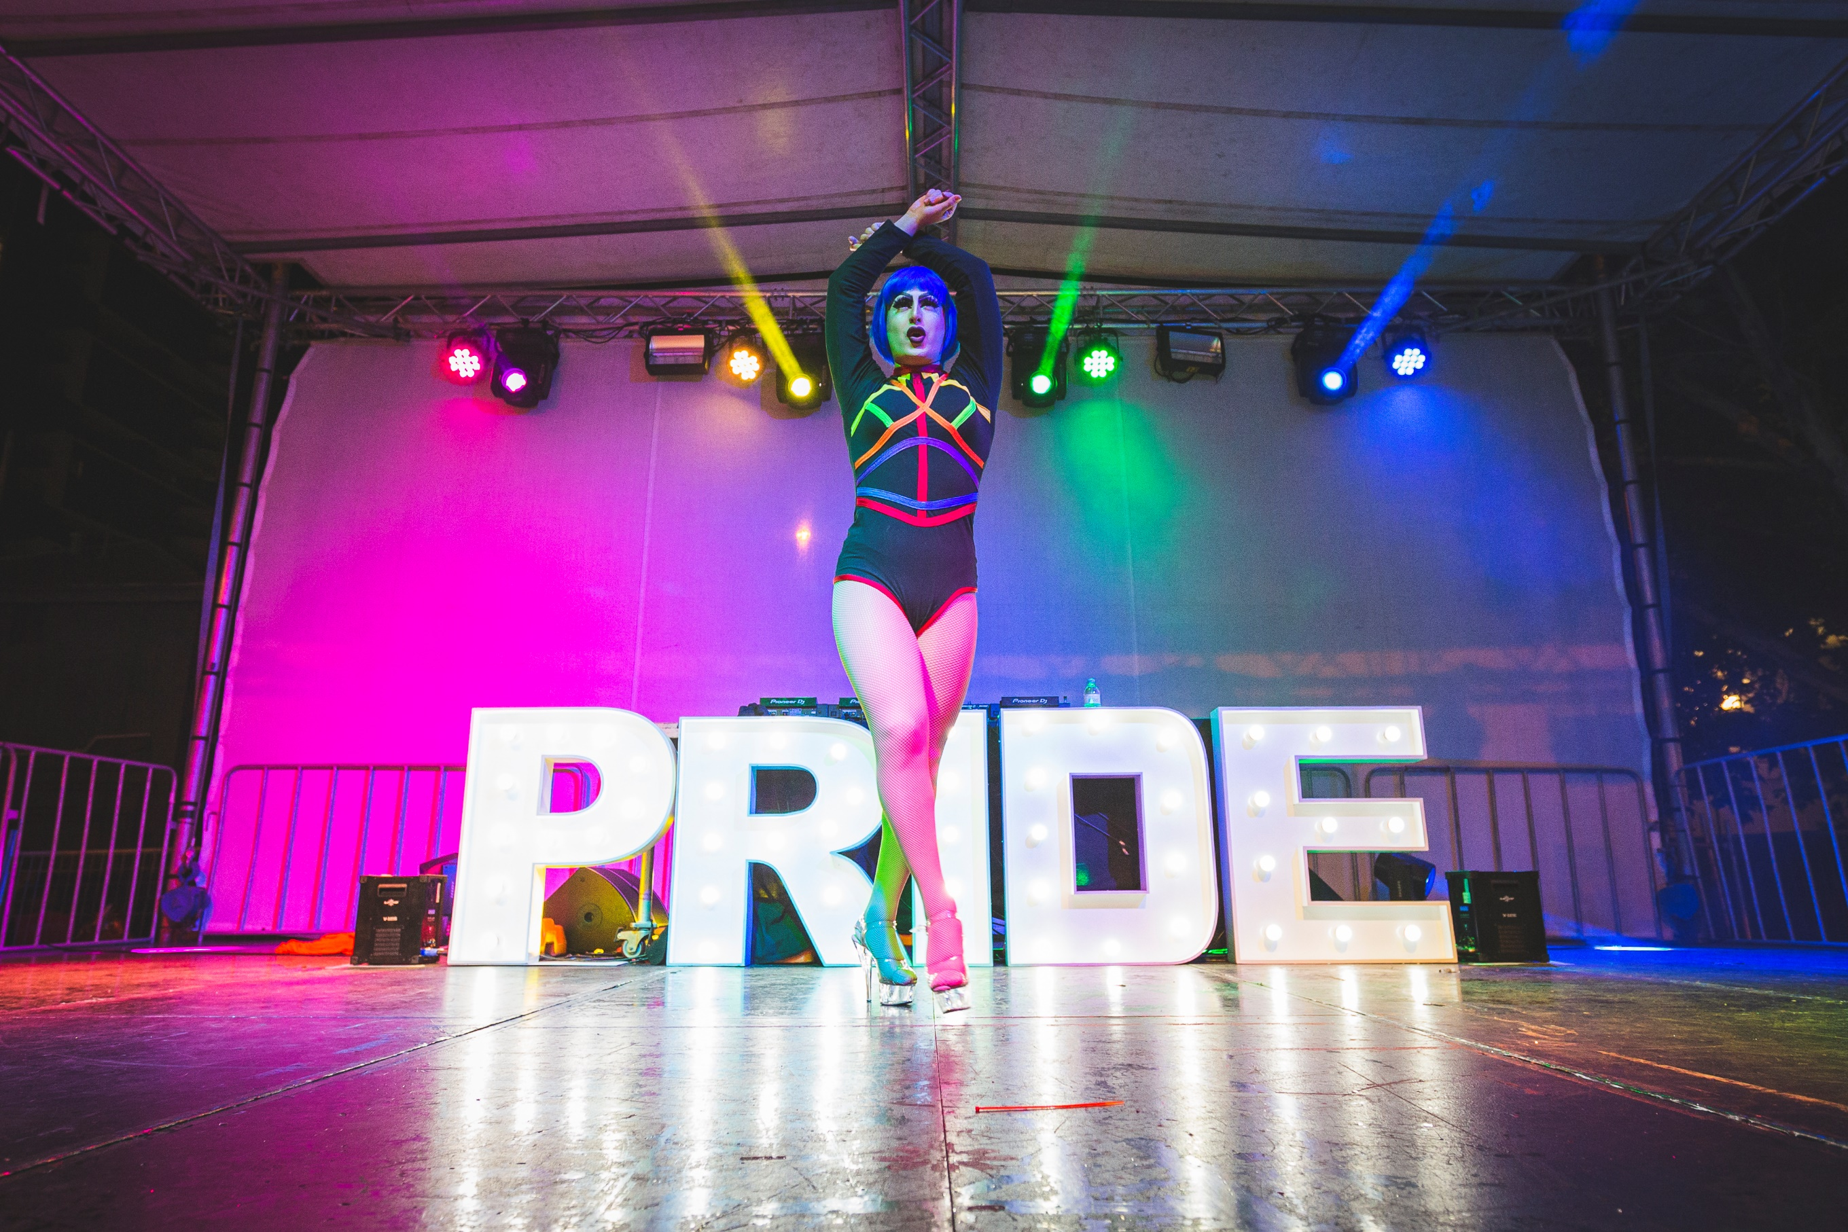

Capital City Advocacy
The City of Perth will use its leadership as a Capital City to advocate with the community on these priority positions.
Position | The Ask | Action Area/s
Security and law enforcement to be trained allies to the LGBTQIA+ community. | - Police Officers and Transit Guards to complete LGBTQIA+ ally training and trans awareness training.  - Discussion around appropriateness of marking willing Officers and Transit Guards as safe ‘allies’.  - The appointment of a LGBTQIA+ liaison officer at Perth Police Station and lock up. | Safety  Education  Visibility
Increase the number of public all gender bathrooms in the City of Perth. | - Amend the building code related to bathrooms to increase accessibility to all people and genders. | Safety  Homelessness  Welcoming and Accessible Services

Position | The Ask | Action Area/s
Support LGBTQIA+ friendly/LGBTQIA+ specific homelessness services. | - Build on existing research into the needs and experiences of LGBTQIA+ people in Perth who are experiencing homelessness.  - Increase the capacity of community organisations who deliver support services to the families of LGBTQIA+ people, with the aim of reducing the instance of youth homelessness in the LGBTQIA+ community.  - Provide recurrent funding and build the capacity of homelessness service providers that operate in the City to have LGBTQIA+ inclusive policies, practices and guidelines, and trained personnel. Focusing particularly on services for LGBTQIA+ youth, seniors, Aboriginal and Torres Strait Islander people and CaLD communities.  - LGBTQIA+ friendly homelessness services to be located in the inner-city.  - Delivery of LGBTQIA+ inclusive crisis accommodation and refuges to meet the immediate needs of all LGBTQIA+ people experiencing homelessness, including younger and older people.  - Delivery in line with the National LGBTI Housing and Homelessness Practice Guide 2020. | Homelessness  Welcoming and Accessible Services
Healthcare services that are LGBTQIA+ inclusive, provide bodily autonomy and are sensitive to the unique needs of intersex and trans and gender people. | - Stop unnecessary medical interventions on intersex people of all ages, especially those unable to consent.  - Delivery of the “WA LGBTI strategy 2019-2024”. | Healthcare

Position | The Ask | Action Area/s
Incorporate social outcomes in relevant legislation that are applicable to major developments (including how the project will improve LGBTQIA+ indicators). | - Incorporate social outcomes in relevant legislation that are applicable to major developments (including how the project will improve LGBTQIA+ indicators). | Welcoming and Accessible Services

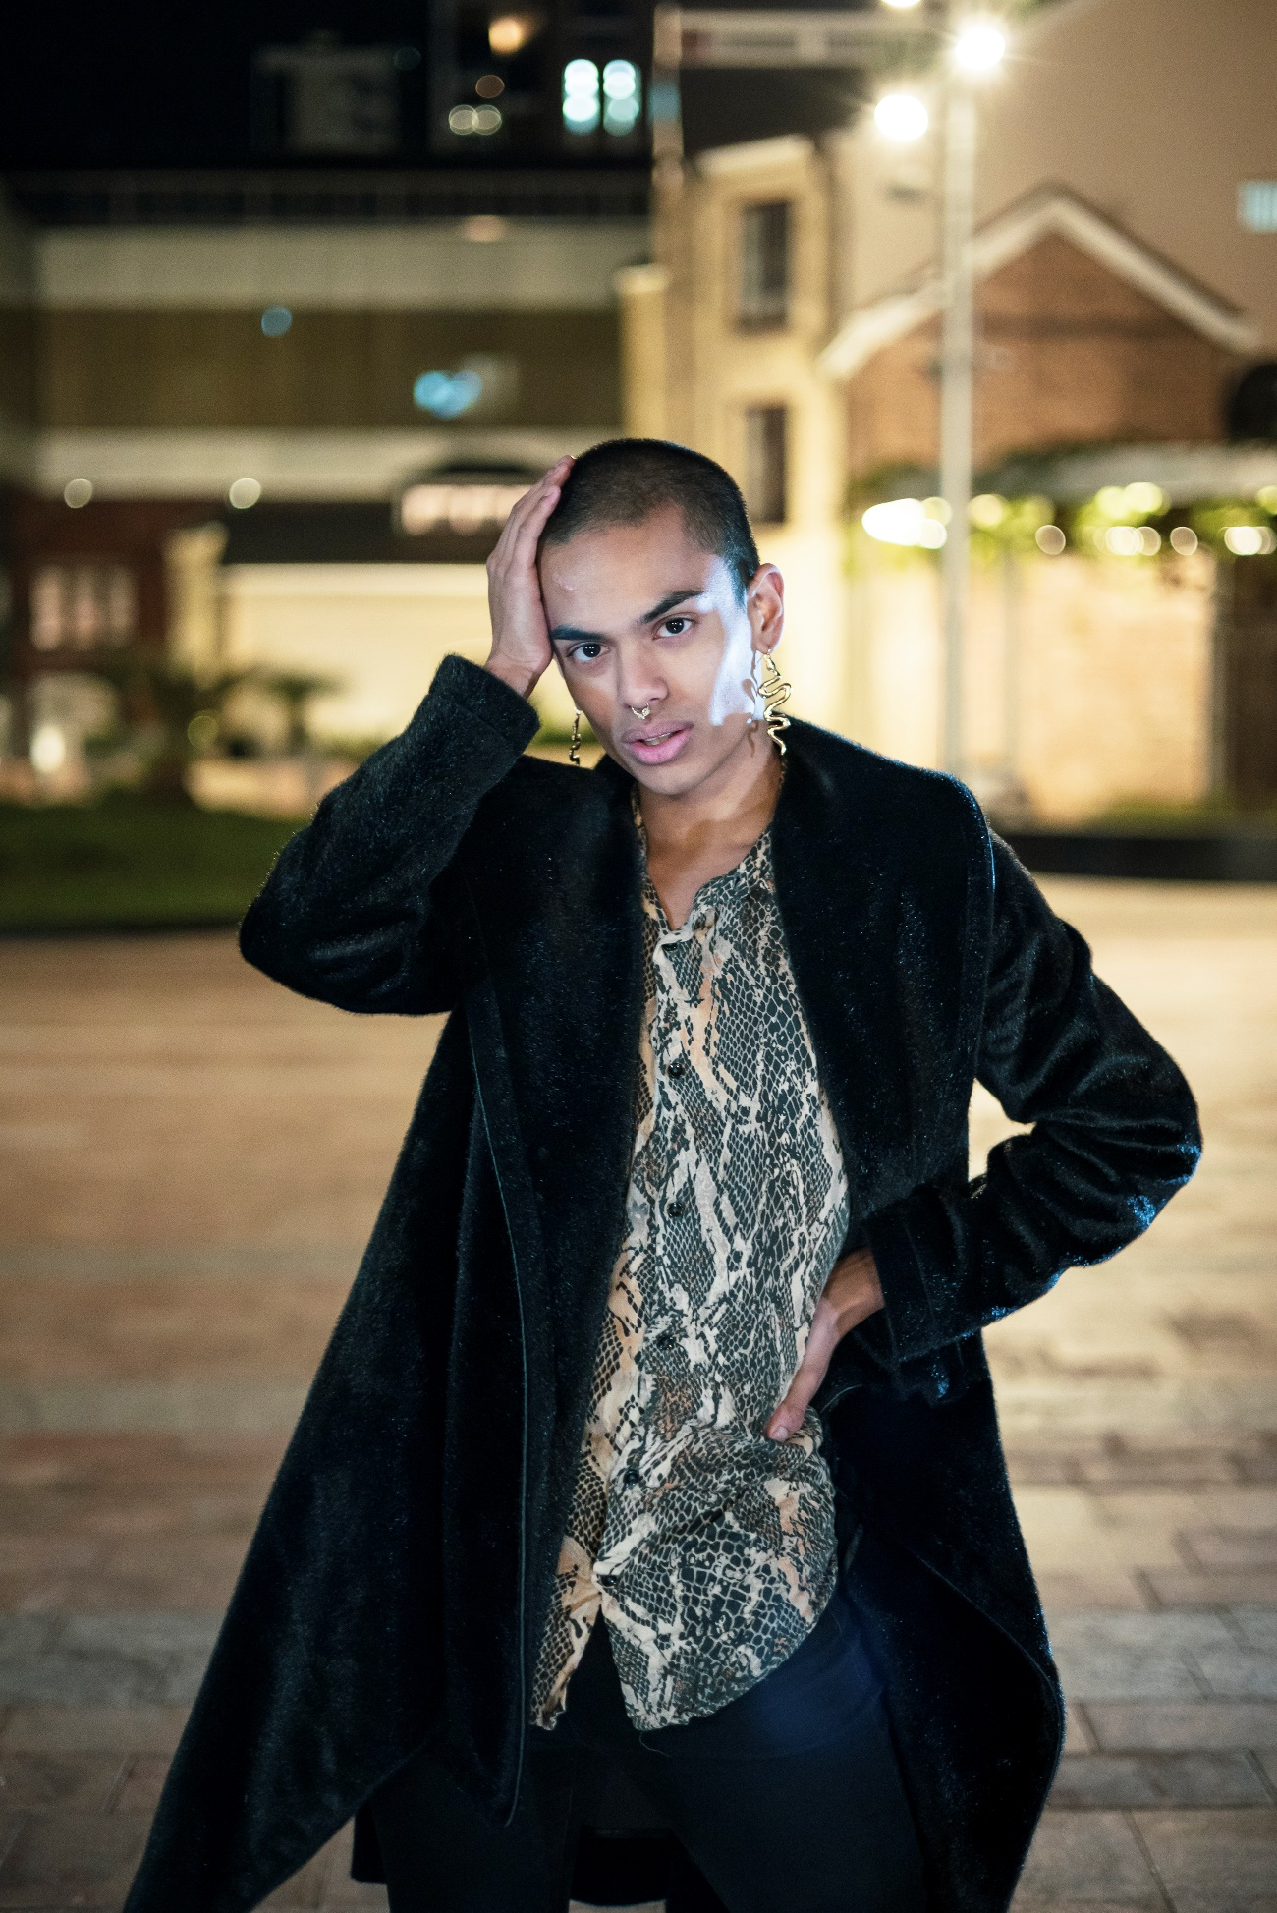
Evaluating the Plan
The LGBTQIA+ Plan will be reviewed and evaluated through:

Glossary
Language is constantly evolving and frequently contested. The below definitions are not definitive nor is it an exhaustive list of terms. The City of Perth supports the right of people to identify their sexual orientation, gender identity or intersex status as they choose.

Ally
An ally is a friend and active supporter of the LGBTQIA+ community. Someone outside of the community can be an ally and members within the community can be allies to each other.
Asexual
A sexual orientation where a person experiences little to no sexual attraction, although can experience romantic attraction.
Bisexual
Someone of any gender who is sexually, emotionally or romantically attracted to people from more than one gender.
Cisgender
People whose internal gender identity matches the sex they were assigned at birth. Cisnormative is the assumption that everyone is cisgendered and erases the existence of transgender and gender diverse people.
Gay
Typically, someone who self-identities as a man and is primarily sexually, emotionally or romantically attracted to other people who identify as men. Some men use other terms to describe their attractions and people of other genders also choose to use this term.
Gender affirmation / sex affirmation / transition
The process a trans or gender diverse person may undertake to live as their defined gender identity. It involves socially, physically and/or legally changing their gender and/or sex. It could include changing names, using different pronouns, presenting differently through clothing or hairstyles etc. But it may also involve physically changing one’s body through hormonal therapies, surgeries or cosmetic procedures and/or changing the legal sex markers on officially documents like birth certificates, passports and licenses.

Gender identity
A term to describe someone’s own understanding of who they are (e.g., woman, genderqueer, man, no gender, etc.), as distinct from their physical characteristics (Q Life).
Gender queer / non-binary
Terms used to describe a gender identity that doesn’t conform to the traditional male-female gender binary. This can include people who are gender fluid, identify as more than one gender, identify as being without a gender (agender), or something else entirely.
Heteronormative
The world view that promotes heterosexual relationships as the normal or preferred sexual orientation and is the main cause of discrimination for people with different sexual orientations.
Homophobia / Biphobia
Negative beliefs, prejudices and stereotypes about people who are not heterosexual.
Intersex
An umbrella term for people with physical characteristics that are seen as different from modern medical norms about ‘female’ and ‘male’ bodies. There are a variety of different intersex variations and intersex physical characteristics do not reliably determine someone’s gender identity or sexual orientation (Q Life).
Lesbian
Someone who self-identifies as a woman and is primarily sexually, emotionally or romantically attracted to other people who identify as women. Some women use other terms to describe their attractions.
Pansexual
Someone whose sexual, emotional or romantic attraction is not defined by gender.
Pronouns
Pronouns are words used to refer to a person. They include gendered pronouns like he/him and she/her, or gender-neutral pronouns which are sometimes used by gender diverse and non-binary people, like they/them.

Queer
‘Queer’ has been used as a slur in the past but has since been reclaimed by a portion of the LGBTQIA+ community. It is an umbrella term encompassing a wide range of identities and is often used by people wishing to indicate that their sex, gender and/or sexuality sits outside of the normal ideas of sex, gender and/or sexuality.
Sex characteristics
Sex characteristics are biological and physiological characteristics that includes chromosomal configuration, hormonal profile, reproductive organs and secondary sex characteristics such as breasts, body hair and voice (WA Department of Health, 2019).
Sexual orientation
The terms used to describe an individual’s sexual, emotional and/or romantic attraction to another person. Someone can identify with a sexual orientation/sexuality regardless of their sexual or romantic experiences.
Transgender & gender diverse
People whose gender identity is not typically associated with their assigned sex at birth. Transgender people may or may not take steps to live as their affirmed gender through dress, legal status and/or medical treatment and surgery. Trans people have the same range of sexual identities as anyone else and their sexuality is related to their gender identity, not their sex assigned at birth.
A variety of terms may be used by transgender people to describe themselves including: man, woman, transwoman, transman, trans masculine, trans feminine, trans or non-binary. The terms ‘sistergirls’ and ‘brotherboys’ are sometimes used in Aboriginal and Torres Strait Islander communities to refer to transgender people.
Transphobia
Negative beliefs, prejudices and stereotypes about people who are transgender or gender diverse.
+
A symbol that represents everything on the spectrum of sexuality and gender that isn’t otherwise captured.

References

Australian Bureau of Statistics. 2020. City of Perth Estimated Resident Population. https://profile.id.com.au/perth/population-estimate.
Department of Health. 2012. "Australian Government, National Lesbian, Gay, Bisexual, Transgender and Intersex (LGBTI) Ageing and Aged Care Strategy."
Hillier L, Jones T, Monagle M, Overton N, Gahan L, Blackman J, Mitchell A,. 2010. Writing Themselvesin 3: The third national study on the sexual health and wellbeing of same sex attracted and gender questioning young people. Melbourne: Gay and Lesbian Health Victoria, The Australian Research Centre in Sex, Health and Society, La Trobe University.
Intersex Human Rights Australia. 2019. Intersex population figures. September 16. https://oii.org.au/16601/intersex-numbers/.
LGBTQ DV Awareness Foundation. 2021. LGBTQ Domestic and Family Violence. https://www.dvafoundation.org/about.
National LGBTI Health Alliance. 2020. Snapshot of Mental Health and Suicide Prevention statistics for LGBTI People. February . https://www.lgbtiqhealth.org.au/statistics .
Q Life. n.d. "Q Life Guides Glossary." Q Life. https://qlife.org.au/uploads/QLife-Tip-Sheets-Glossary.pdf.
Strauss, P., Cook, A., Winter, S., Watson, V., Wright Toussaint, D., Lin, A. 2017. Trans Pathways: the mental health experiences and care pathways of trans young people. Summary of results. Perth, Australia: Telethon Kids Institute.
Western Australian Department of Health. 2019. Western Australian Lesbian, Gay, Bisexual, Transgender, Intersex (LGBTI) Health Strategy 2019–2024. Perth: Health Networks, Western Australian Department of Health.

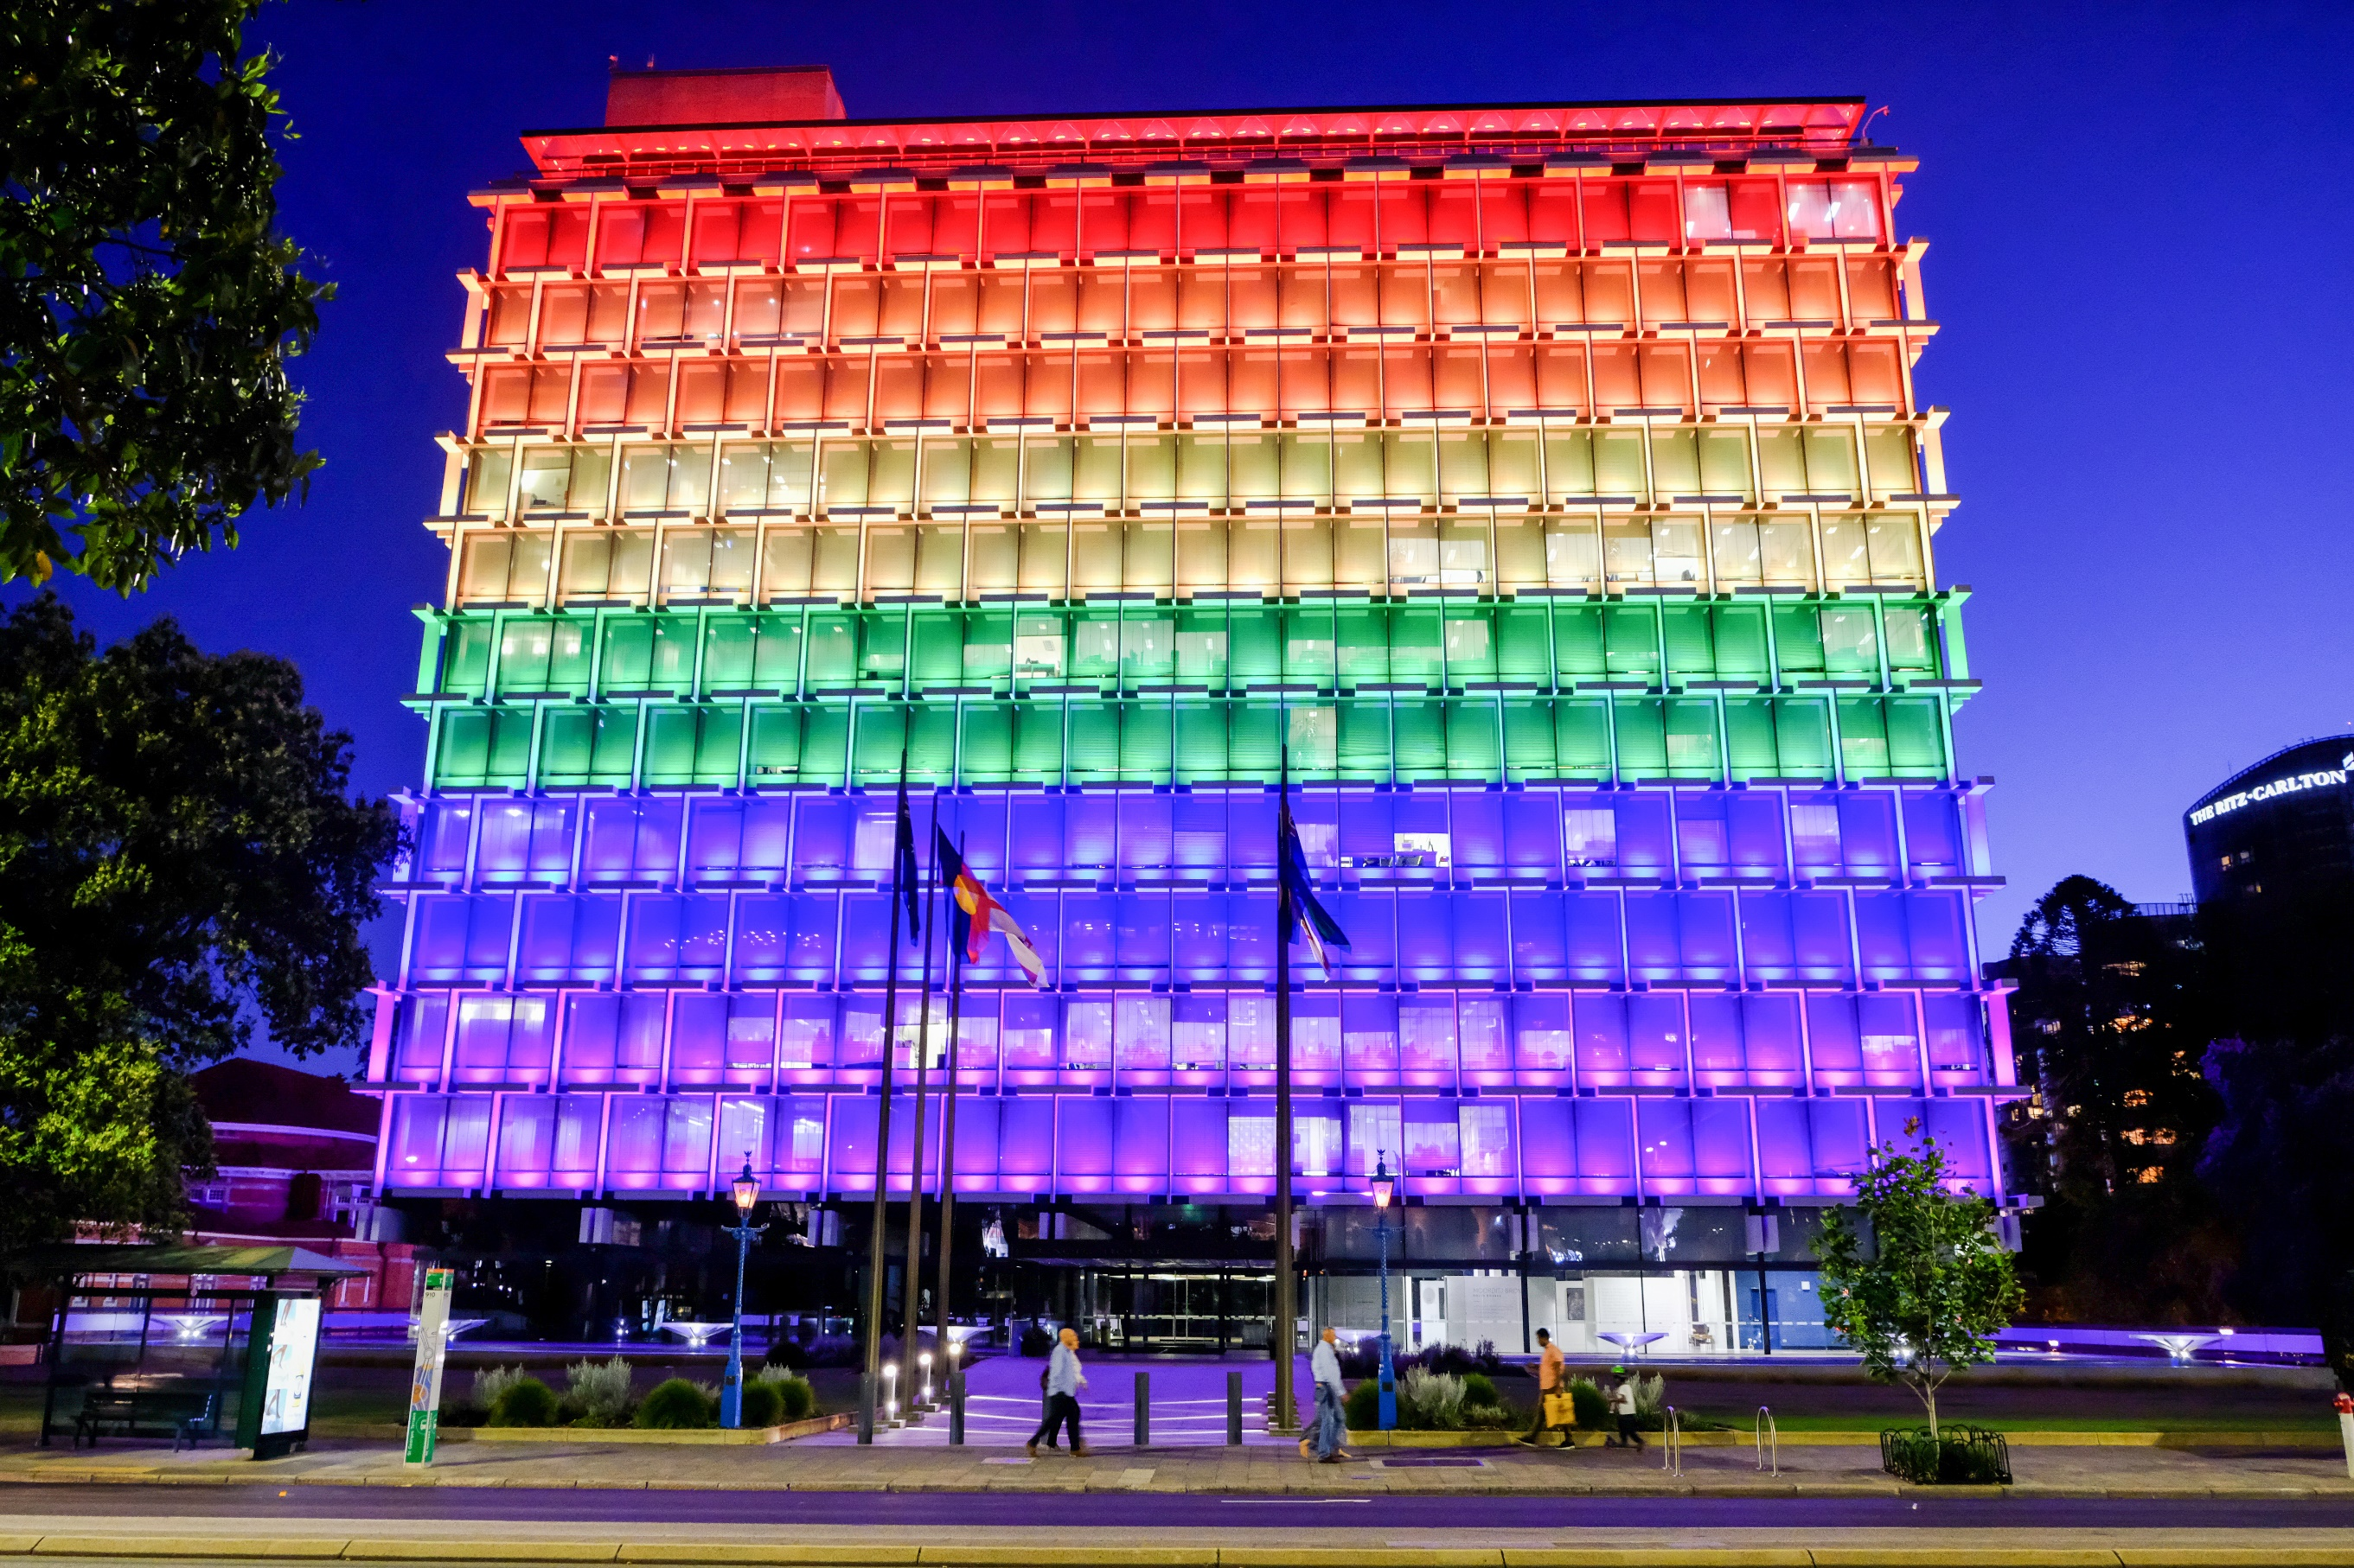

City of Perth
27 St Georges Terrace, Perth
GPO Box C120, Perth WA 6839
Telephone: (08) 9461 3333
Email: info@cityofperth.wa.gov.au
perth.wa.gov.au

United Nations Human Rights Office of the High Commissioner 2015

