
Narrows Interchange (Exercise Equipment)
Location 1: on the west of the southern lake in David Carr Memorial Park
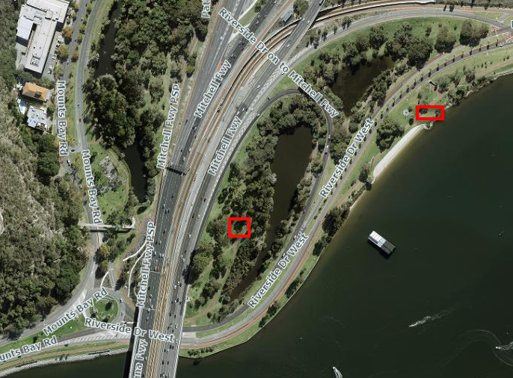
Location 2: along the Exhibition Centre foreshore, with access via Riverside Drive

