
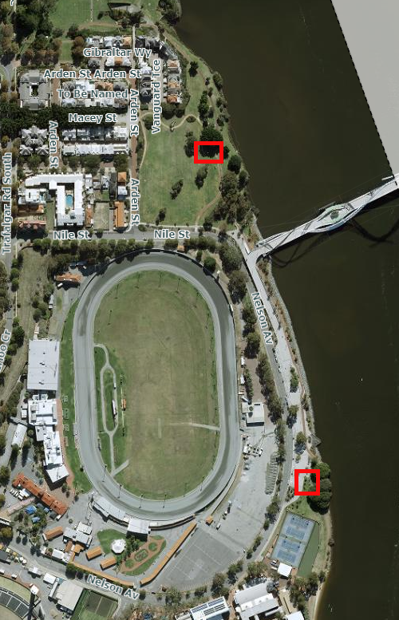
East Perth Foreshore (Exercise Equipment)
Location 1: adjacent Arden Street Reserve which is accessed via the public shared path, on Nile Street
Location 2: adjacent Nelson Avenue, directly north of Trinity College and is accessed via Nelson Avenue.

